**SEDS/SSPI 2018 Design Competition**

**Space Tug**



**Table of Contents**

**Concept Art** **2**

**Systems** **3**

**Business** **8**

**Structures** **13**

**Electronics** **22**

**Power** **30**

**Propulsion** **31**

**Orbital Mechanics Approximation** **38**

**Propellant Feed** **41**

**Future** **47**

**Sources** **48**

# Concept Art

# 

# 

# 

# 

# 

# 

# 

# 

# 

# 

# 

# 

# Systems

**Mission Statement:**

To provide safe, reliable, consistent, and cost effective transportation of cargo from Low Earth Orbit to any cis-lunar or low-lunar orbits. Cargo missions may range from satellite deployment to delivering of cargo to a base in lunar orbit.

**Overall System Requirements**

Argo is a space-tug designed for multiple trips between LEO and lunar orbit while carrying an upwards of 34 metric tons of cargo. It is also designed to be capable of delivering satellites to GEO or lunar orbits. The structure, electronics, and data acquisition systems must support the load and provide control over a multiple mission lifespan. The estimated mission time is anywhere from 45 days to 95 days, dependent on the mass of the cargo Argo is transporting. The ideal lifespan from launch is 30 clients in 7 years of continuous operation. Argo will be retrofitted in the event that future technology facilitates either full recovery of the vehicle or continuous maintenance. When the operational lifespan of Argo has been exceeded, and reliability can no longer be guaranteed to our potential contracts, the craft will be transitioned to a heliocentric graveyard orbit; therefore ensuring the craft does not orbitally decay into Earth’s upper atmosphere, which would cause a disassembly of the craft and its reactors, and a subsequent spread of radioactive material across the Earth.

**Individual Subsystem Design Objectives**

Electronics:

* Provide positioning control based off of telemetry data
* Control maneuvers between target orbits
* Shall be properly insulated and protected
* Shall give navigational feedback for correct routing during orbit transfers

Propellant Feed:

* Deliver xenon from the main storage tank to the thruster head.
* Maintain a low leakage rate and robustness
* Piping should be strong enough to hold high pressure xenon
* Provide a range of mass flow rates, making the thrusters throttleable
* Receive and Transmit accurate pressure readings at multiple locations within the system

Propulsion:

* Provide reliable thrust, enabling Argo to reach its destination
* Have a tenacious operational lifetime, which maximizes overall profits on the craft
* Thrusters need to provide range of thrust to properly maneuver the vehicle

Attitude control system (ACS)

* Must provide alignment during rendezvous maneuvers

Structures:

* Structure must be load bearing while on the ground, and provide structure during orbit raising, maneuvers, and launch.
* Withstand the launch load and vibrations without deformation
* Radiators must reject heat, making the performance of the spacecraft nominal.
* As enabled by the business case, modularity must be incorporating to the extent of facilitating specific part replacement as needed. This is currently designed as replaceable engine and reactor buses (cores) that developing servicing satellites can remove with future infrastructure improvements.

Power:

* The three reactors should be able to support all electronics and telemetry systems, as well as the propellant feed system and thrusters, with proper power regulation
* Withstand the potential differences within the system.

Shielding:

* Provide protection against micro-meteorites, and radiation emitted from the sun
* The craft needs to be properly insulated from the extreme temperature range in space
* Insulation of parts throughout craft, preventing thermal damage resulting from, and occurring between, the parts themselves
* Maintain the operational constraints of temperature and pressure of all parts

**Concept of Operations**

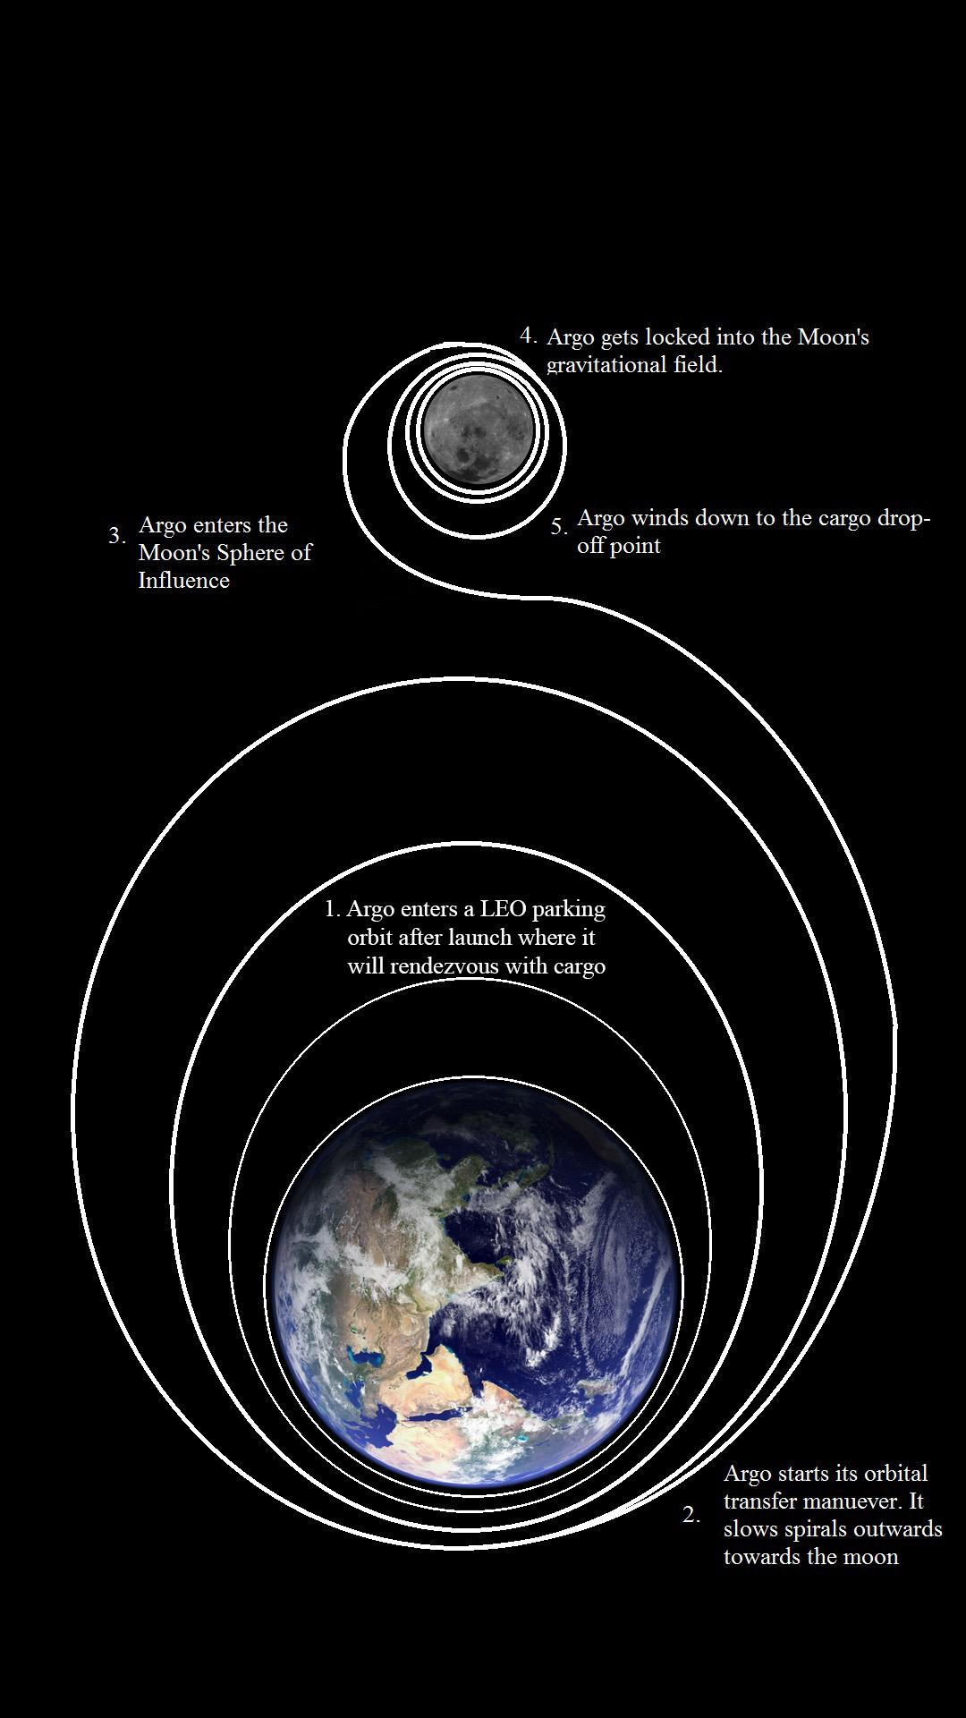

Figure 1: Concept of Operations

**Safety Plan and Risk Management**

Overview

Argo is a large spacecraft with radioactive and other hazardous materials on board. Many precautions are required before, during, and after launch to prevent adverse environmental damage and ensure personnel safety. The nuclear reactors are the greatest concern, requiring the implementation of proper techniques for safe operation and disposal.

Redundancy/Strength

Systems within Argo are made redundant where possible so that if a single part within the structure, fuel lines, etc., then the whole system is not jeopardized. Dual propellant feed systems, excluding the main tank, exist to sustain the extended life cycle. The main tank’s lack of physical redundancy will be compensated for through a high safety-factor in its manufacturing. The structure of the spacecraft is being constructed out of high strength titanium and aluminum alloys so that the structure is able to bear the 720kN of launch force that it will experience if the vehicle is sent up loaded with one round-trip worth of fuel.

Guidance/Correction

The thrusters can be throttled or shut off to make trajectory corrections. The ACS system also allows rotation and translational movement for rendezvous maneuvers and the robotic arm allows for final alignment when we are within range (about 2 meters and 90 degrees of orientation).

Vehicle Retirement

If the vehicle is no longer capable of powering itself within LEO, then the reactors present major health and environmental risk. The equipment and system on Argo are limited to the operational lifespan of the thruster heads. The primary life limited item is the thruster heads as they have the shortest lifespan of all the components on Argo and ceasing thruster operation results in the loss of the ability to accelerate, regardless of the performance of the other subsystems. This can potentially be extremely dangerous given that, if we have an engine failure, we cannot control Argo and it may result in the craft entering the atmosphere. After the completion of approximately 10 missions (more or less depending on mission length and the mass carried), or if it is determined the thruster heads are too worn to risk another mission, the craft will sent into a heliocentric graveyard orbit. This type of orbit will provide the minimum possibility of it crashing into Earth and will prevent adding clutter to usable cis-lunar orbits. The Argo reactor and engine cores are modular so that a refitting craft in the future could remove the spent systems safely and place new cores to upgrade and increase the life-span of Argo.

**Standard Operating Procedure**

Three design reference missions have been evaluated in the development of Argo; cargo transport from LEO to GEO (or other cis-lunar orbits), large mass cargo transport from LEO to Low-Lunar Orbit (LLO) (up to 34 megaTonnes), and regular resupply missions from LEO to LLO for a theoretical deep-space gateway. While these missions were the primary focus during the development of Argo, other possibilities exist. Some of these possibilities include; repositioning satellites, station-keeping, and even transport of heavy cargo to Mars (though travel times would be measured in years). The following SOP details three standard missions starting from Argo being stationed in LEO.

LEO to GEO, LEO to LLO (heavy), LEO to LLO (resupply)

* Argo is stationed in a LEO parking orbit, cargo is launched into LEO using traditional rockets and rendezvous to be assisted by second stage of launch vehicle.
* Cargo detaches from the second stage of its launch vehicle, and the second stage moves away, Argo approaches and orients itself with ACS and, when close enough, uses its robotic arm for final alignment and latches onto the cargo at its separation ring.
* Argo orients itself and can initiate either a low thrust orbit transfer from LEO to GEO, or Earth to moon, depending on its mission
  + LEO to GEO transfer time: under 7 days
  + LEO to LLO (heavy) transfer time: 150 days
  + LEO to LLO (resupply) transfer time: 40 days
* Argo positions the cargo in orbit and releases from fairing adapter. (final alignment, if necessary, is done by cargo)
* Argo begins low thrust transfer orbit to return to LEO where it will rendezvous with its permanent refueling station.
  + LLO to LEO (empty craft): 40 days
  + GEO to LEO (empty craft): 7 days
* After filling with xenon propellent via the robotic arm, which is launched up 60 MT at a time and stored in LEO periodically, Argo moves to parking orbit to await its next mission.

# Business

**Market Research**

Many companies, like Lockheed, ILS, and Orbital ATK, and SSL are moving to capitalize on the open market of refueling, repairing, and repositioning existing satellites, but most have not been focusing on the necessity of cargo transportation. The In-orbit Servicing Market (IoSM) is projected to exceed over $3 Billion over the next 10 years(“In-Orbit Servicing Market…”). However, a much larger market may soon exist. NASA has been developing a plan for the deep-space gateway: a cis-lunar or lunar orbit station designed to be humanity’s next stepping stone to returning to the moon and travelling to Mars. The president of the USA has also posted a Memo requesting NASA to consider returning to the moon and possibly developing permanent infrastructure there. The initial budget to create the station is estimated at $2.7 billion, with a estimated $500 million or more of that going to launches and transportation of cargo and modules. In order to make these stations viable for housing humans there must be reliable cargo shipments of resources (like food and water). This is analogous to the near-monthly resupply of the ISS; however, on a far larger scale given the distances involved and amount of cargo required. It is a painfully inefficient use of time, money, and resources to regularly send chemical rockets to GEO or lunar orbit. What the market needs is a safe, reliable, and relatively inexpensive way of regularly sending supplies to these stations, and that is where Argo comes into the picture.

Cost Analysis: Resupplying the ISS

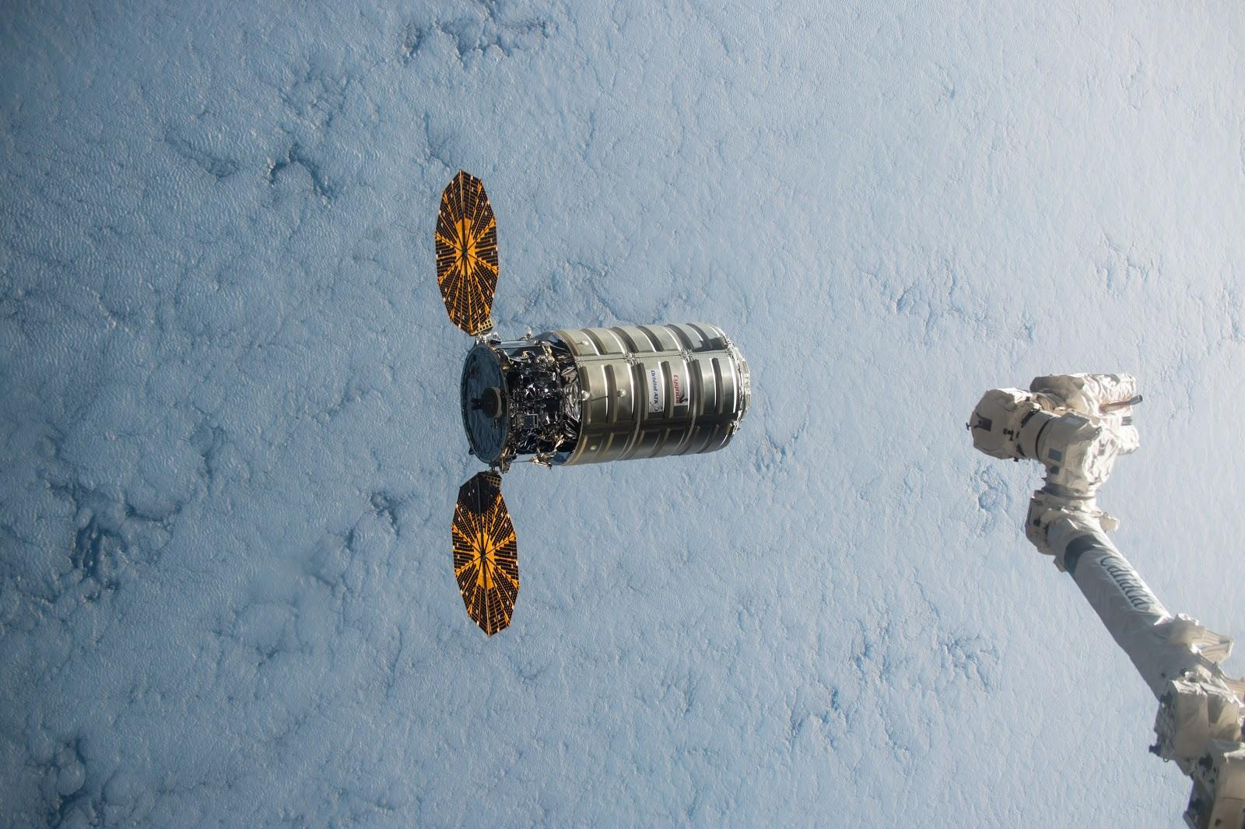

Figure 2: Example of a Resupply mission to the ISS, representative of commercial opportunities in space

|  |  |  |
| --- | --- | --- |
| **ISS Resupply** | **SpaceX: Falcon 9** | **Orbital ATK** |
| **Cost of Contract Per launch (Millions USD/MT)** | 70 | 100-125 |
| **Actual cost to company (Millions USD/MT)** | 30.6-40 | 75-100 |
| **Mass of Payload (MT)** | 2 | 2 |

Table 1: ISS Resupply Costs

The ISS is resupplied on a near monthly basis with all member nations sharing the cost of supplies and launch. While Argo will not be used for resupplying the ISS in LEO, this is an example of the type of missions that will need to be done for stations at GEO or in LLO. With missions costing more, we estimate that missions to supply the deep-space gateway or a lunar base would be run on a quarterly basis and thus would require up to 6 MT minimum of basic cargo (food, water, components) plus up to 30 MT for construction materials.

Cost Analysis: GEO and LLO

|  |  |
| --- | --- |
| **To GEO** | **SpaceX: Falcon 9** |
| **Propellent (MT)** | 273 |
| **Payload (MT)** | 4 |
| **Cost (Millions USD)** | 63 |

Table 2: GEO cost and payload

|  |  |
| --- | --- |
| **To LLO** | **NASA SLS** |
| **Propellent (MT)** | 338 |
| **Weight Payload (MT)** | 26 |
| **Cost (Billions USD)** | 7.5 |

Table 3: LLO cost and payload

Research, Development, and Operation Expenditures/Value

|  |  |
| --- | --- |
| **Space Tug Cost Analysis** | **Costs (Millions USD)** |
| **Research Costs** | 800 |
| **Non-recurring production costs (R&D divided amongst 3 initial units)** | 266.6 |
| **Recurring production cost** | 121 |
| **Cost of putting each unit into LEO (via Falcon Heavy)** | 45 |
| **Asset depreciation per mission (assuming 10 missions per unit)** | 43.26 |
| **Launch and servicing, cargo insurance** | 20 |
| **Cost of propellent per mission (10 tons)** | 0.07 |
| **Cost of launching propellent via Falcon Heavy (10 tons)** | 15 |

Table 4: Forecasted expenditures and value

|  |  |
| --- | --- |
| **Total cost to company per mission** | 91.7 |
| **Cost to Customer (with standard 20% profit margin)** | 110.00 |
| **Cost with launch (Falcon Heavy) 34 MT cargo to LLO** | 210 |
| **Cost Per Kilogram to LLO (Thousands)** | 5.65 |

Table 5: Forecasted overall costs

Research costs are estimated through typical Lockheed Martin satellite research production costs when contracted to NASA. Estimates based off of communication satellites were used due to there design for repeatability, large scale, and relatively simple system goals. These satellites are designed to be stationed at GEO so their electronics packages and overall architecture is designed to survive the high-radiation environment, similar to the constraints on Argo. Production costs per unit were also estimated using production costs for communication satellites given that they are often repeatedly made from a single design (and thus do not have as much research costs included in their production costs). The overall cost per unit is determined by taking the research and development costs, dividing them by the number or initial units, and adding it to the cost of production of each tug. Given that we offer a transportation contract we also must charge for insurance on our cargo in case of tug failure during mission.

With a profit margin of 20-40% per mission, it would take 6 missions per space tug (approximately 3-4 years) before Argo would be profitable.

**Business Considerations**

Expenditures

Research, development, and initial launch of Argo comprises of a majority of our expenditures.

Partnerships

We would likely partner with NASA to develop the space tug (similar to how SpaceX developed the Dragon capsule and Orbital ATK developed their Cygnus capsule) as they could provide funding and access to other partners and technologies. We would also want to partner with Orbital ATK for mission planning and craft operations given their reliable reputation.

Contracts

Initial contracts would be through NASA and would likely take the model of the space station construction/resupply program. Many countries and companies could use our system for LEO to LLO (or GEO) but we would be contracted directly with NASA. This is similar to the contracts that SpaceX and Orbital ATK have with NASA to resupply the ISS.

**Business Structure**

Infrastructure Development Missions

Argo would be used to transfer supplies and modules for developing stations at GEO and LLO. These stations would likely be larger than the ISS and would require multiple trips’ worth of materials. Argo is capable of carrying up to 34 tons within 6 months, round trip. When launch aboard the Falcon Heavy is included(the cheapest option to send 34 MT into LEO), each mission would cost our customers approximately $210.34 million.

Resupply Missions

Missions to resupply a deep-space gateway or lunar base will likely be far shorter (on the order of weeks instead of months) than infrastructure missions, given the far lower weight. We estimate a round trip duration of 2-3 months, allowing Argo to perform up to 20 resupply missions in its 5 year minimum lifespan. These contracts (including launch costs via Falcon 9 of 10 MT payload) would total approximately $132.16 million per mission to the customer.

**Argo Advantages**

Argo provides a highly-efficient and reliable infrastructure solution for deploying mass amounts of cargo beyond LEO. Transportation and insurance costs are minimized by reliability, consistency, safety, and reusability and then passed on to the consumer. Alternatives, like chemical rockets, do exist and can complete the missions we are targeting in days. However, chemical systems have a higher chance of catastrophic failure, which can make a deep-space gateway station a risky investment. Chemical rockets also require thousands of tons of propellent to run the same missions and the second stage units are not reusable. These issues increase overall project costs, and decrease the feasibility of investment. Argo makes investment in these mission lucrative enough to bring in funds that will make these stations and infrastructure possible.

# Structures

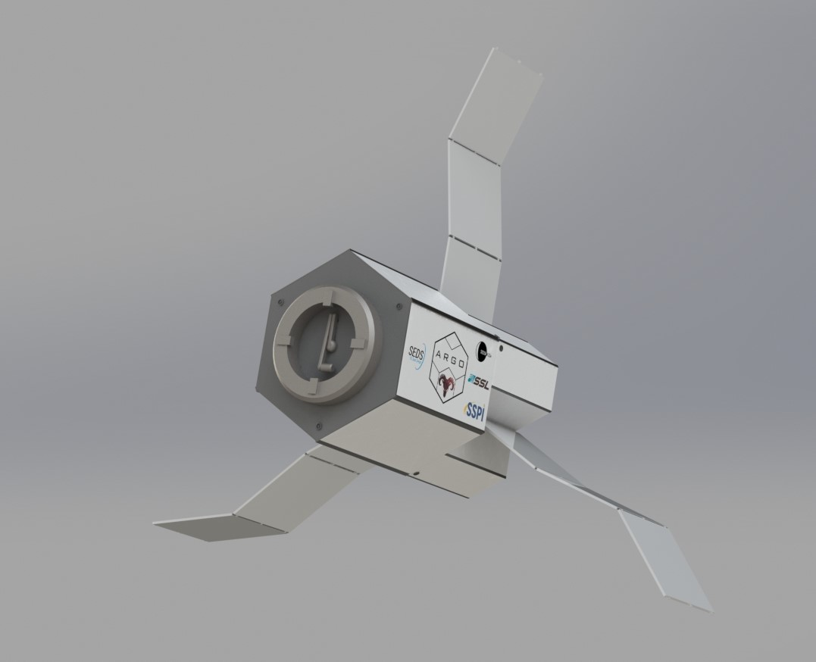

Figure 3: Full Argo Space-Tug

**Structural Overview**

The structure of the Argo space tug is designed to be modular, durable, and reliable. It must be able to withstand the 720 kN axial load imposed on the vehicle during the launch sequence at maximum acceleration as well as the acoustic environment. The figure above shows an isometric view of the vehicle. The major structural subsystems shown above are the following: bus, tank, reactor containment structures, radiators, insulation/shielding, fairing mount/cargo interface. Propellant feed mounts are located within the structure.

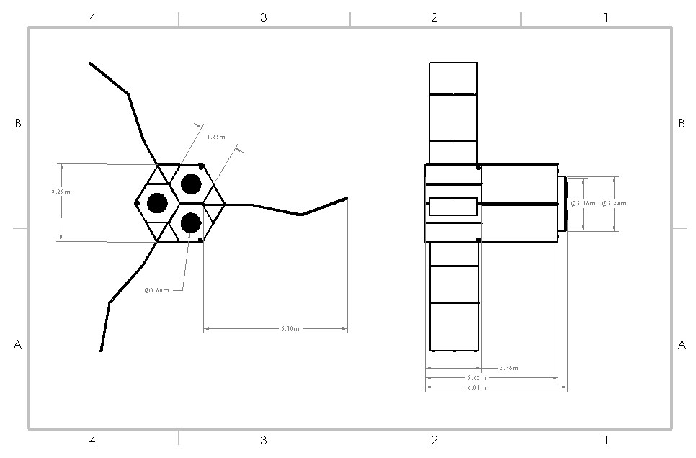

**Mass Budget**

|  |  |  |
| --- | --- | --- |
| **System** | **Subsystem** | **Estimated Weight** |
| **Structures** | Frame | 1,700kg |
|  | Tank mount | 100kg |
|  | Plumbing Mounts | 200kg |
|  | Electronics mounts | 30kg |
|  | Cargo mount/Fairing mount | 100kg |
|  | RCS mounts | 30kg |
|  | **Total** | 2,160kg |
|  |  |  |
| **Shielding** | Tank Shielding | 20 kg |
|  | Electronics Shielding | 20 kg |
|  | Bus shell | 50 kg |
|  | **Total** | 90kg |
|  |  |  |
| **Plumbing** | Tanks | 180 kg |
|  | Valves | 20 kg |
|  | Piping | 50 kg |
|  | Mounts | 20 kg |
|  | **Total** | 270kg |
|  |  |  |
| **Power** | Reactor with Brayton Power system | 600 kg x3 |
|  | Heatsinks/Infrared radiators | 100 kg x3 |
|  | Electronics (for sustaining power system) | 10 kg |
|  | **Total** | 2,110kg |
|  |  |  |
| **Electronics** | Control | 50kg |
|  |  |  |
| **Propulsion** | Engines | 250 kg x3 |
|  | RCS thrusters | 50 kg x3 |
|  | **Total** | 900kg |
|  |  |  |
| **Total** | **5580kg** |  |

The Bus

The bus is the primary structure of the spacecraft. It is the main load-bearing structure during the take-off sequence aboard the launch vehicle, and it is where the tank and main electronics are located. The bus is constructed using a combination of aluminum and titanium alloys. While titanium is stronger, it is much more cost effective to use aluminum. Where the frame does not experience as high of loads, aluminum will be used.

The structure of the bus is a hexagonal prism, with the hexagonal faces being located on the ends height-wise. From one face to the other it is 3.225 m. The distance between the two parallel faces of the prism is 3.243 m, fitting into the launch vehicle fairing. The space inside the bus ensures there is enough room for the main fuel storage of xenon, and most major electronics and transmitting equipment. The width of the hexagonal cross-section and height of the main bus structure may decrease if the structure is larger than it needs to be.

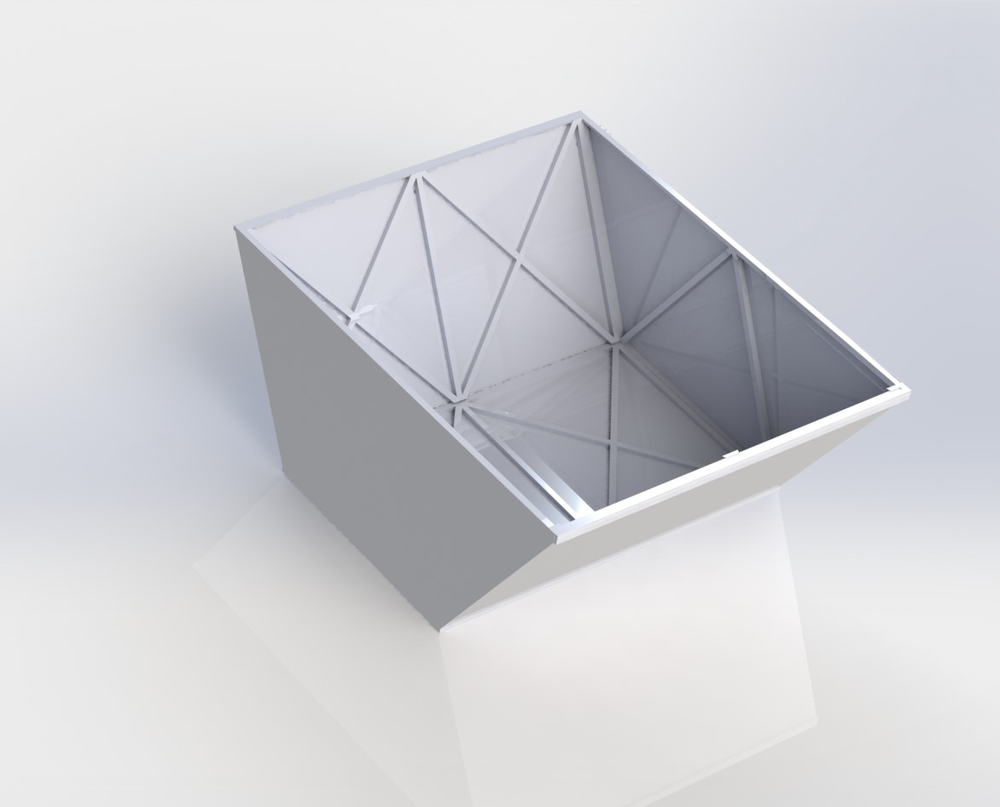

Figure 4: Main Bus Structure

Main Tank

The largest storage tank in the bus contains xenon, which powers the thrusters. The main tank is a composite overwrapped pressure vessel (COPV). A very large tank is desired, because it optimizes space and weight. However, if any faults or leaks are found during testing and fabrication of the tank, with helium or nitrogen to make leaks easily detectable, the xenon will be distributed to several smaller vessels which would be very similar in size. This multiple tank option would make the filling of the xenon feed system slightly more complicated as there are multiple tanks, however testing could determine the optimal way to do this. This will be further discussed in refueling methods. Another option would be fixing the design of the original tank and requalifying.

The tank shell is made of a carbon fiber, Torayca T-1000 and 31-43 b resin. The liner is made of an aluminum alloy. Lining the tank is Al 2219-T62, chosen for its high strength.

The tank is approximately 2.5 meters in diameter, yielding 45.43 kilograms of storage. There is a single opening which allows gas to flow between the propellant feed system. It will experience pressures up to 1500 psi during operation. Smaller scale versions of this tank have been shown to not fail until over 10000 psi (Ray), while maximum operating pressure for these tanks is 6000 psi. The large margins between the op pressure and burst pressure reduces development risk. Testing would also verify that the larger version of this tank has pressure thresholds analogous to smaller versions. The tank requires a heater, which will use excess heat generated by the reactors.

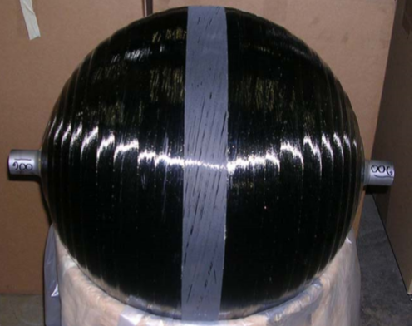

Figure 5: Scaled down tank. Courtesy of Ray/NASA

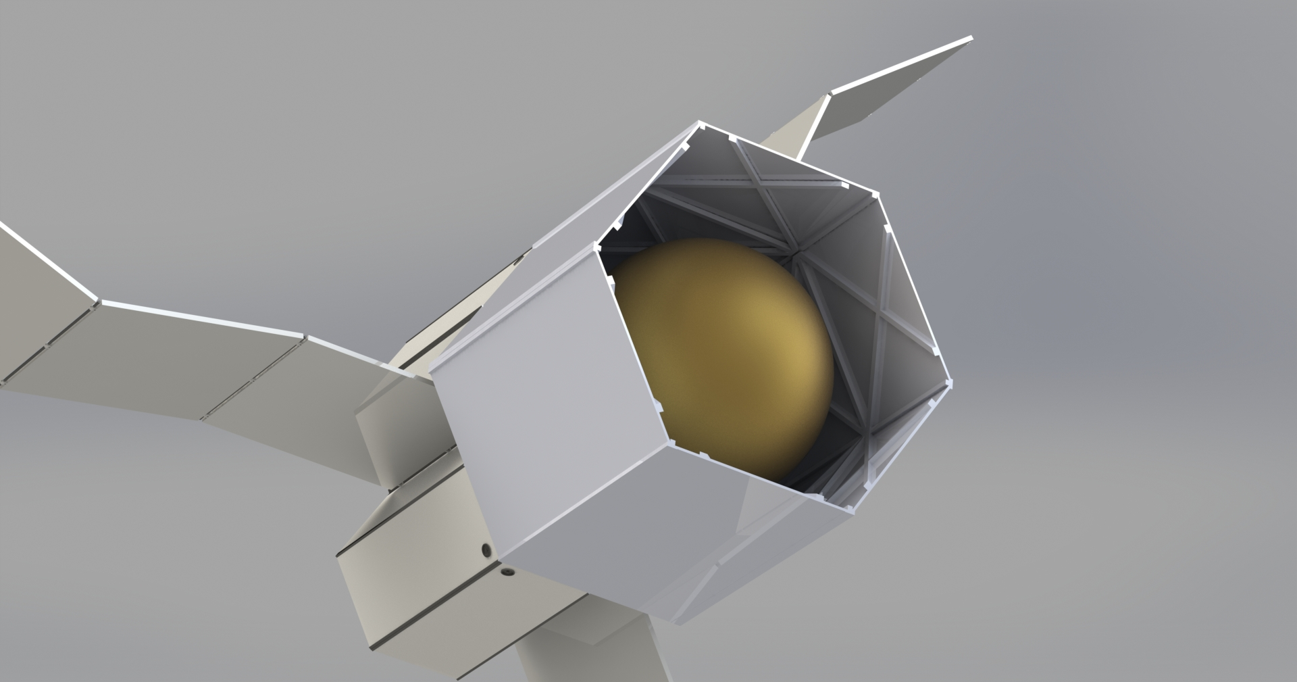

Figure 6: Mock Tank structure in Bus. It is gold because of the insulation wrapping it.

Thruster Head and Reactor Busses/ Containment structure

On the back of the space tug are three scaled structures in parallel alignment with the main bus. Each scaled bus contains a reactor to power its respective thruster head, cross-strapped for redundancy, as well as a low pressure system which is discussed in the propellant feed section. Careful insulation of the reactors will be incorporated to prevent interference between the propellant feed and electronic systems. From one parallel face to another is 1.635 meters. The length of the bus is 2.37 meters, with a total structure length within a faring of slightly over 5.5 meters.

The main components in the interior of the structures above are the reactors and their insulating equipment, and the propellant feed systems. Notice the hole in the leftmost face of the structure in Figure 7, this the location of the X3 thruster. As with the main bus, the height and the size of the hexagonal faces of the reactor busses will decrease if space can be further optimized.

Figure 7: Secondary Bus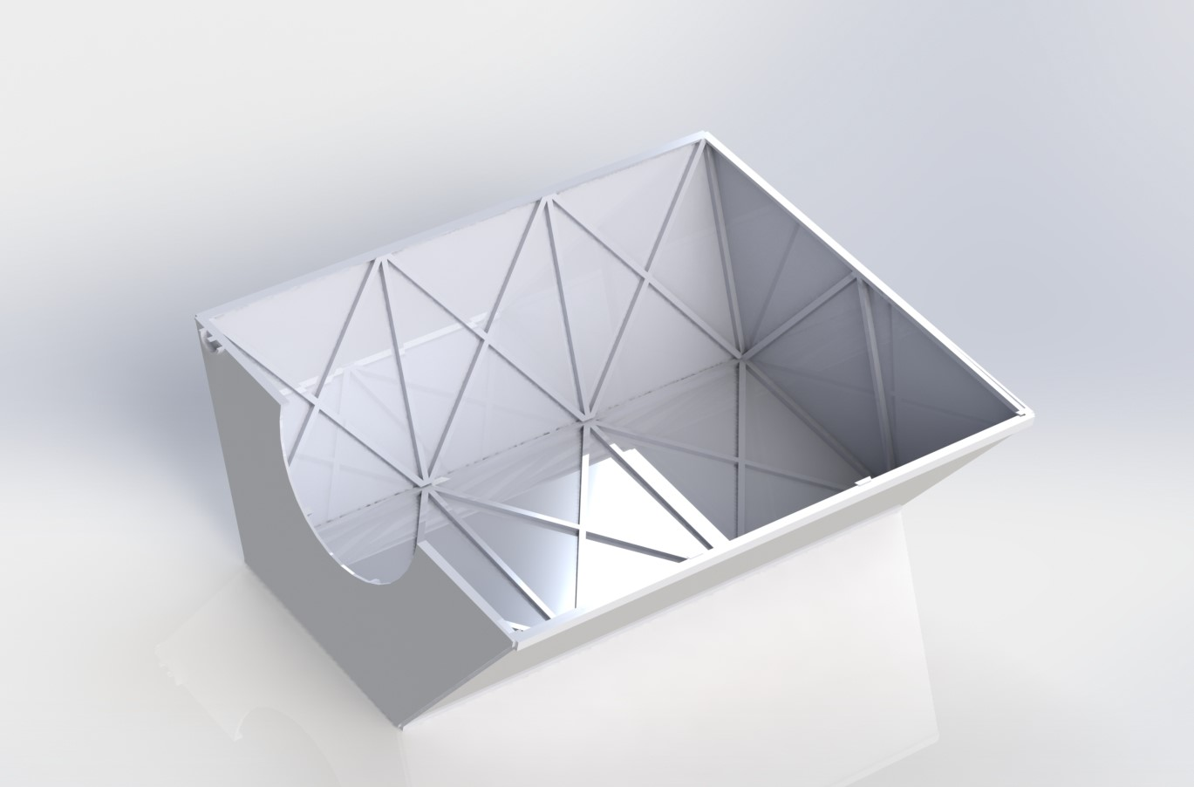

Insulation and Shielding

The plumbing system, including the main xenon tank and its pipes, will be shielded from temperature changes by Multi-Layer-Insulation (MLI), which is comprised of multiple thin layers of common satellite-insulating materials. Due to the need to radiate heat generated by the nuclear reactors away from the spacecraft, the bus structure will have no thermal shielding.

The sensitive electronics inside Argo will be protected from radiation by a graded-Z shield. This type of shielding consists of a high-Z material (Tantalum) sandwiched between two layers of a low-Z material (Aluminum). Thermal shielding of the electronics with MLI is has potential for consideration.

Radiators

Three sets of infrared radiators are attached to aft portion of the craft on the reactor busses. They will be folded during the launch sequence, within the empty space around the containment structures. After separation from the launch vehicle, the radiators will unfold.

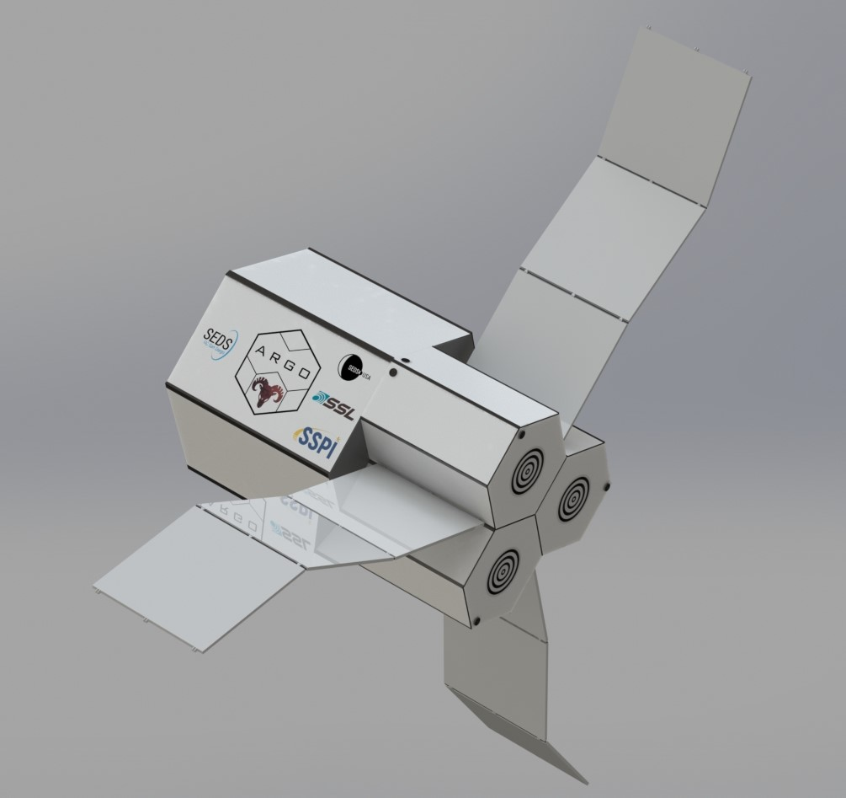

Figure 8: Radiator System

Launch Vehicle Adapter Ring

Argo’s fairing mount is the tug’s means of securing itself its vessel during its travel from Earth. The fairing mount is located on the posterior hexagonal face of the craft, and designed to be compatible with the mechanical payload interfaces of crafts such as SpaceX’s Falcon 9. The diameter adheres to their specification of 1 ½ meters (Explorations); furthermore since the craft will have a medium payload mechanical interface, it will operate in design and functionality in accordance with its respective EELV Standard Interface Specifications. In addition, the fairing mount is made to be reusable and modular in the case of the craft being taken to and from Earth by different crafts. The fairing mount is pneumatically actuated by the xenon already within the system.

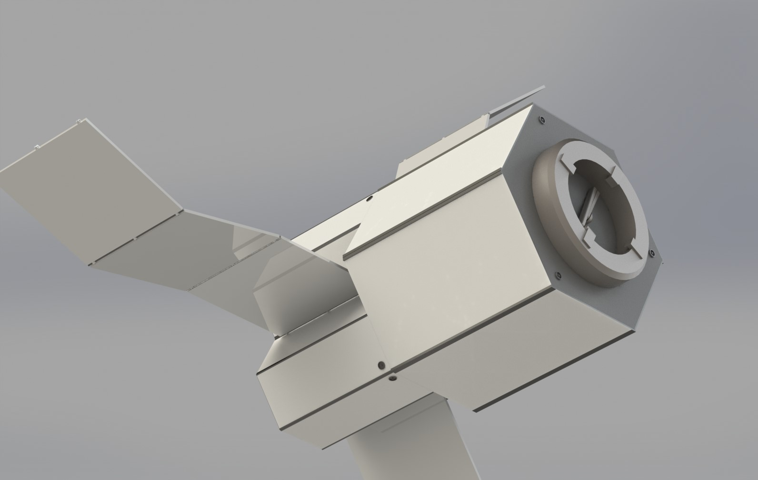

Figure 9: Fairing and Robotic Arm. Note the thrusters

Robotic Docking Arm

The docking arm is inside of the fairing ring. When Argo is close enough to the payload, the arm reaches out, in a manner comparable to the Canadarm on the ISS, aligns the fairing rings, and mounts the cargo to Argo with the arm acting as the load path.

Thrusters

Thrusters are built into the system and utilize on-board xenon as their propellant. They are located around the space tug to provide attitude control. Figure 9 provides possible thruster locations. The locations chosen are currently shown to maximize their possible efficiency.

Plumbing Mount

A plumbing system, consisting of aluminum and titanium pipes, will carry xenon from the tank to the propulsion system through use of a pressure differential. Due to the relatively small size of the plumbing system, within the support structures the individual components of the system - valves, pipes, and three small tanks per thruster - will be mounted on an interior vertical wall onto a metal plate. This plate will provide stabilization and support throughout Argo’s launch and time in space. The materials chosen will serve to maintain the pressurization of xenon throughout the system, as well as preventing corrosion and fatigue. The exact means of maintaining the system’s designated PSI is described in more detail in the propellant feed section.

# 

# Electronics

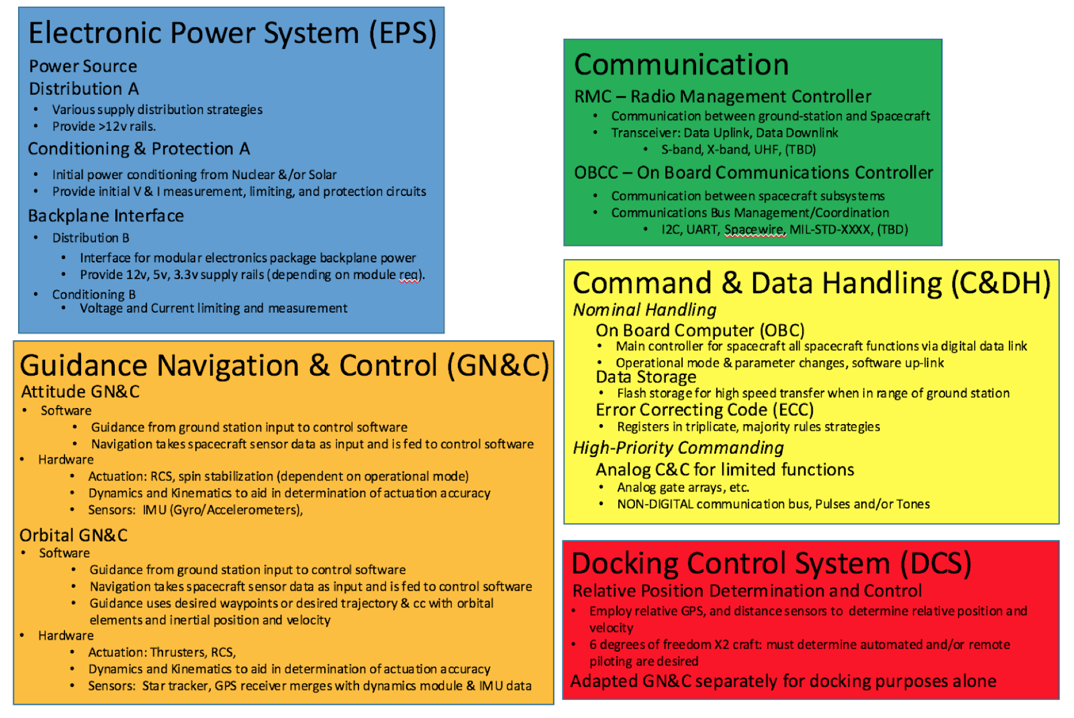

Figure 10: Electronics System Overview

**Control Systems Overview**

The control systems for Argo will be capable of Guidance, Navigation, and Control (GN&C) in LEO and LLO. These systems will also be responsible for making many complex maneuvers during Rendezvous and Proximity Operations (RPO) with cargo, and orbital maneuvers.

Argo’s normal operation conditions, such as radiation and temperature, dictate many aspects of the control systems design. Many aspects of Argo’s GN&C architecture are affected by our choice of propulsion as well, which as the techniques necessary to ascertain and achieve the desired orbital paths.

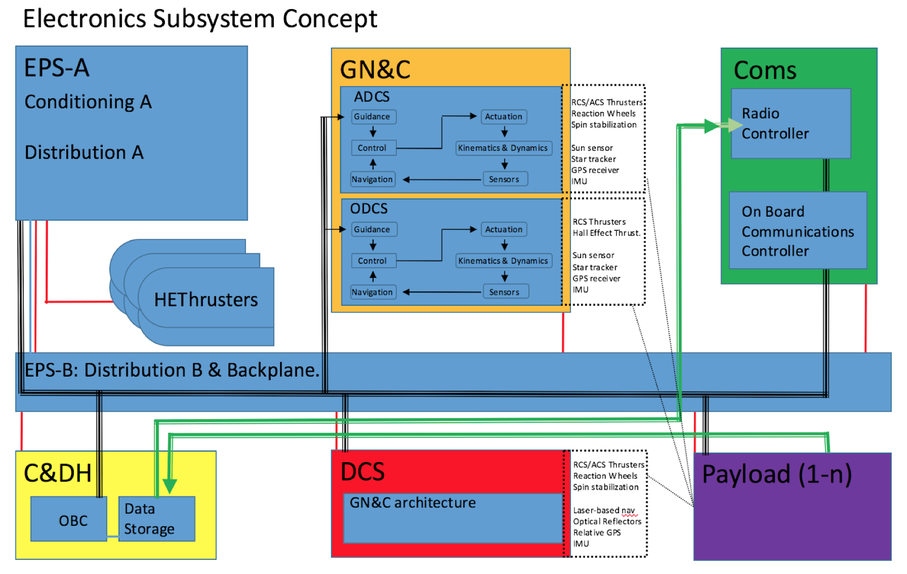

Figure 11: Electronics systems conceptual diagram. High speed data lines are double-lined green arrows, low-speed data lines are represented by triple-lined black arrows, and single red lines represent power via backplane. In this diagram, ‘high speed’ and ‘low-speed’ bit-rates are defined relative to those of the Universal Serial Bus; ‘high speed’ must exceed these rates, ‘low speed’ most likely will not.

**Backplane & ‘Tunnel’ Architecture**

The backplane serves three main functions; namely to provide the electronics tunnel with a reliable power, communication, and structural bus. Argo shall be equipped with three ‘tunnels’, in a three-unit CubeSat standardized structural package, inside of which exists the backplane into which all sub-system modules are integrated. Argo is designed to support the ability to send hard backup modules along with fuel and/or payload modules. Leveraging existing CubeSat standards (such as pea-pod faring adapters) to replace damaged or out of date tunnels with new hardware. The design life of a ten-year operational lifespan, means that it may be necessary to replace electronic hardware before electronics packages have reached their maximum total-dose of radiation.

When in LEO, a replaced electronics tunnel will allow Argo to potentially always have a functional electronics module with an extremely low level of radiation exposure; adding to the robustness of the entire system when using majority-rule voting among data registers. While single radiation upsets cannot be shielded against, electronics are traditionally designed with shielding to protect against the constant dosage of radiation exposure in space. However, once the so-called *total dose* is reached, the shielding material in which an electronics package is encased no-longer provides protection. The ability to replace a module while a normal refueling operation is underway, provides Argo with an electronics module that has not been exposed to the radiation that Argo has undergone during its operational lifetime up to that point. This is vital to ensuring that Argo may continue to function nominally throughout its many visits to LEO.

Usual measures for mitigating failures, such as component redundancy; Failure Detection, Isolation and Recovery (FDIR); Silicon on Insulator components; increased insulation materials; and others often add mass, and can only protect against ionization to a finite point. Redundancy often means that backup components are have been exposed to the same Total Ionization Dosage (TID) as the component for which they are called on to take over; ensuring that any given spare will be in the state required at the time of its primary counterpart’s failure is difficult. Radiation hardened components are limited in availability and often orders of magnitude more expensive than Commercial Off The Shelf (COTS) components. COTS components can often withstand up 10 krad of TID and, while Radiation hardened components can be rated to withstand anywhere between 100 krad to 1 Mrad. Since most electronic component defects occur at about 2-20 Krad for TID, radiation hardened components are arguably unnecessary to maintain a ten-year operational lifespan for a spacecraft if we can limit time of exposure through tunnel swapping. Furthermore, shielding techniques and radiation hardening does virtually nothing to protect from single-event upsets, such as latch-ups, most of which are commonly mitigated by way of system design techniques, such as power cycling.



Figure 12: Graph of Total Dose Ionization (Rads) vs. Thickness of Aluminium Shielding (millimeters) (Courtesy ESA)

Argo is designed to rendezvous and dock with cargo vessels and incorporates the ability to refuel in LEO; and so it stand to reason that we should leverage this ability to combat radiation if necessary. Incorporating replacement of a single electronics tunnel & backplane module, potentially even multiple modules, while docking can potentially reduce mass and bolster the resiliency of the entire electronics system with regard to TID. Techniques which add small additional mass, such as conformal coating and thin radiation shielding may certainly still be used in the tunnel and backplane architecture.

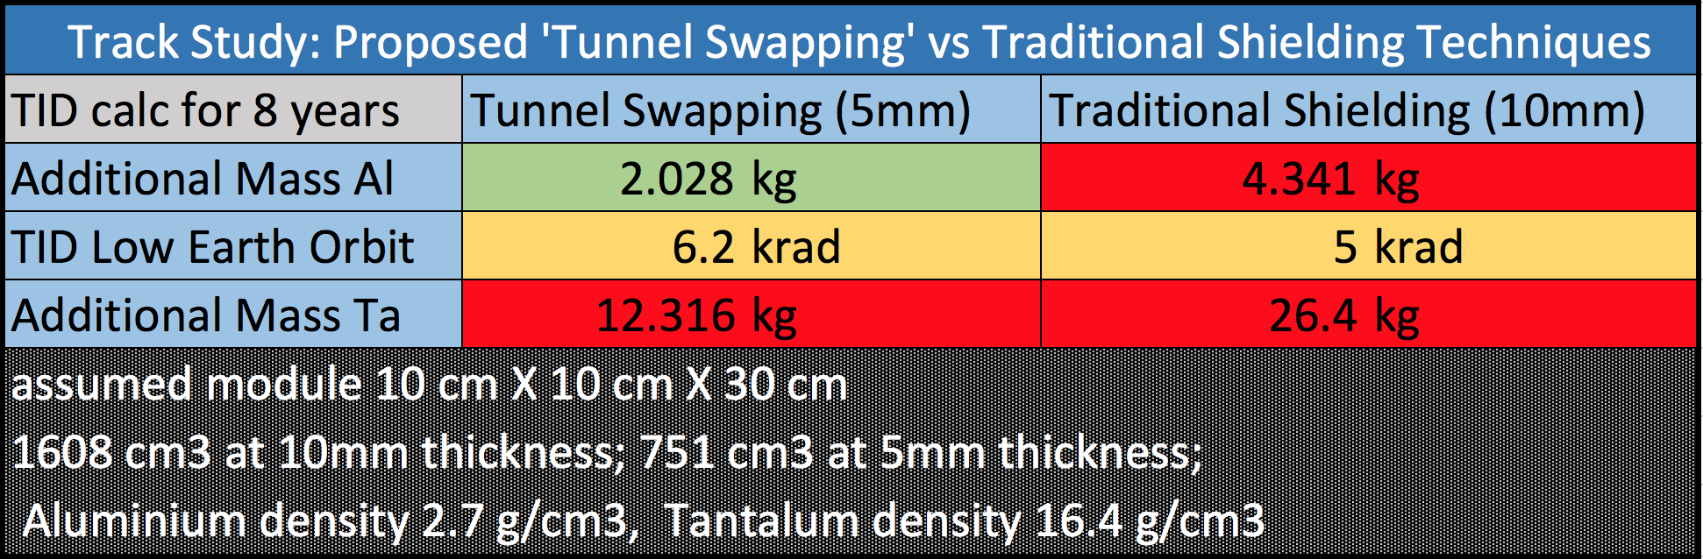

Table 6: Simple Track Study for the proposed electronics package swapping techniques compared to traditional shielding techniques. Over an eight-year period, mass savings are significant when compared to TID protection provided by thick shielding. Note that mass appears to reduced across shielding materials traditionally used for electronics package shielding. A shielding thickness of 5mm was selected as a simple figure for shielding that may still be chosen for tunnel modules. Further research can be done to optimize these thicknesses.

The backplane interface (block B as described below) will be mounted in the rear of the tunnel’s ‘socket’ which will make contact with the rear of each new tunnel at the backplane interface, using gold-plated ‘pogo’ contacts to ensure a strong electrical connection for all power and communication lines between the three modules. While the ‘old’ tunnel has been ejected, two tunnels will still be on board to maintain the space tugs functionality during a tunnel swap.

**Guidance, Navigation and Control (GN&C)**

In general, the GN&C system is responsible for determining a current position, and comparing that position with a given trajectory, and determining which maneuvers may or may not be necessary to correct or maintain the nominal position. In the case of the Argo Space Tug, this is broken down into two main subsystems; Orbital GN&C and Attitude GN&C.

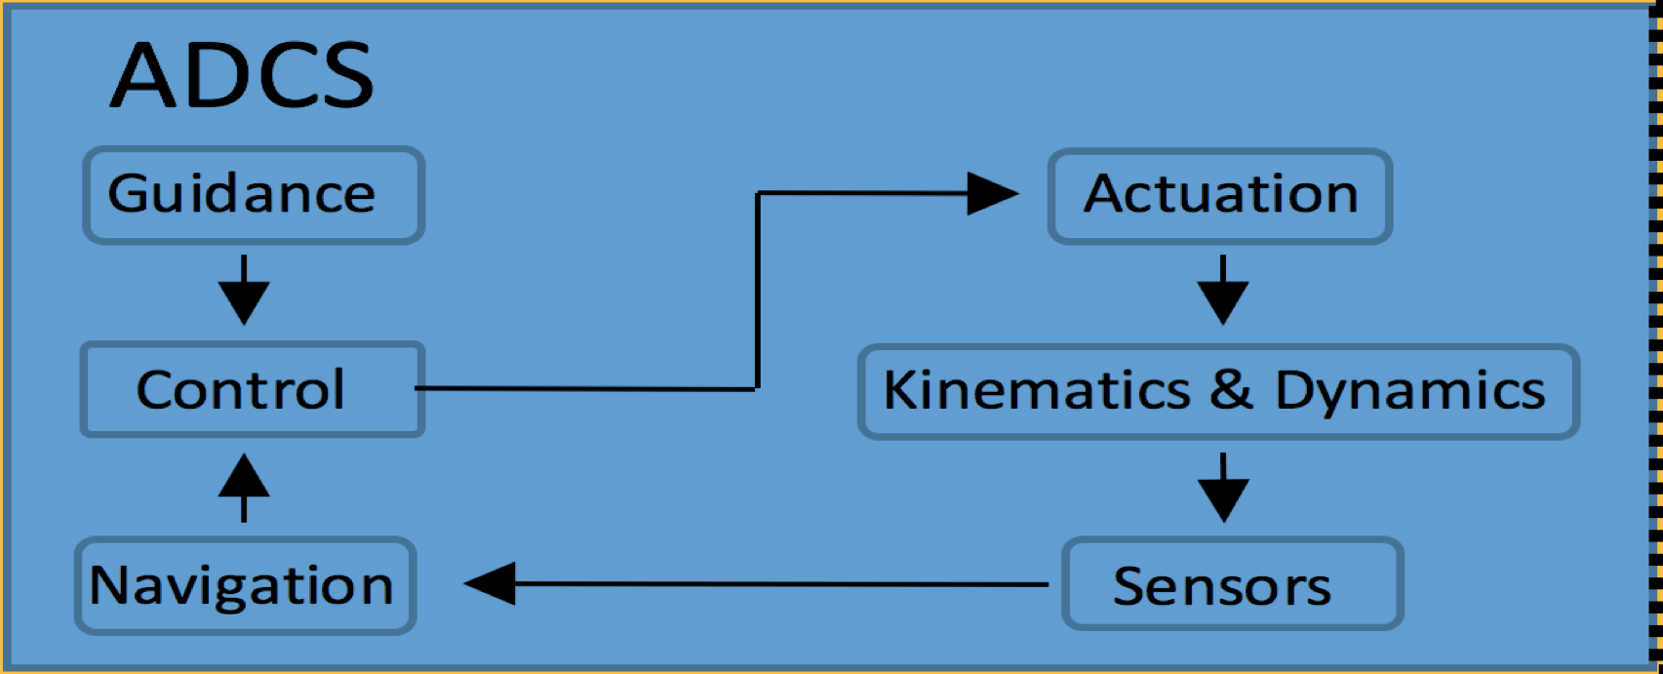

Figure 13: GN&C control flow

Orbit and Navigational GN&C subsystems will have a virtually identical operational control flow. The two subsystems vary only in their sensors, and the task specific actuators; although software will vary greatly between the two subsystems. GN&C communicates with radio and on-board communication managers to receive and transmit data to the ground station and interface with the Command and Data Handling module for more autonomous operation.

Orbit GN&C

Orbital elements *(а,е,ⅰ,ω,Ω)*are ascertained to determine inertial position and velocity, and used for guidance, through the use of the on-board inertial measurement unit (IMU), GPS receiver (especially during LEO cargo RPO), sun sensor, and star tracker. Filters will merge their sensor data with on-board dynamics models to achieve autonomous navigation solutions when ground station interventions are not necessary (nominal operation). Actuation will be delivered by Hall effect thrusters and reaction control thrusters.

Attitude GN&C

Attitude shall be determined based on data from the orbital GN&C sensor set. The ACS thrusters should achieve and maintain stable attitude, but magnetorquers may be implemented to provide lower fuel consumption when located in LEO in a non-critical operational state.

GN&C Command and Data Handling (C&DH)

The command and data handling module will be responsible for handling and communicating sensor data and ground station commands to the orbital GN&C system. The On Board Computer, if able, be used to handle some of the guidance information and dynamics. In the event that communication with the ground station is not possible, the C&DH module will be responsible for storing trajectory data for the downlink. Power consumption of the Command and Data Handling module is estimated to be 1.2 Watts.

**Radio Communications Controller/Manager**

Expected data transfer performance of radio communications is up to 16 kbps downlink and 4 kbps uplink. A high data rate S-band transmitter will be on board and capable of up to 3.4Mbps downlink speeds, which will serve to transmit the data stored on flash storage in Command and Data Handling module. Many transceivers and transmitters which meet these criteria and allow for in-flight configuration of data-rates and output RF power are available. Not including amplification, power consumption of these two components will require a maximum of 24.2 Watts.[1]

On-board Communications Controller/Manager

On-board communication will likely utilize I2C, SPI, CAN and UART protocols. While Space Wire is very reliable, debugging and testing is a vital part of risk mitigation. The accessibility of software and to qualified personnel required to utilize Space Wire is far less than those of I2C, SPI, CAN and UART protocols; and therefore testing communication subsystems can be conducted, and solutions implemented, more often. It is the opinion of the Argo electronics team that increasing the ease of testing and debugging will lead to a more robust system than simply opting to use Space Wire.

The on-board communications manager will act as the master in all serial communication between modules in the electronics tunnel. Data which needs to be ‘translated’ will be stored in triplicate before being sent to the receiving module. In the case of discrepancy in the data, majority-rule ‘voting’ will be used. The data which matches the majority stored will be transmitted. Some of these tasks are likely to be implemented in the On Board Computer (OBC) as part of our data handling subsystem. Power consumption of the on-board Communications Controller/Manager will be factored into the C&DH power budget (~1.2 Watts max).

Communication System C&DH

Flash storage within C&DH will store data until high speed downlink is available, which will then be sent via high data rate S-band transmitter to the ground station. The OBC will assist in on-board communication management and majority-rule voting procedures.

Backplane

The electronics backplane will facilitate communication lines throughout the electronics tunnel. A communication bus will be available to each module for any protocol selected for Argo by using cross-strapping, or 2-for-1 redundant, architecture; ensuring that the failure of any module shall not interfere with data transfer to the other modules.

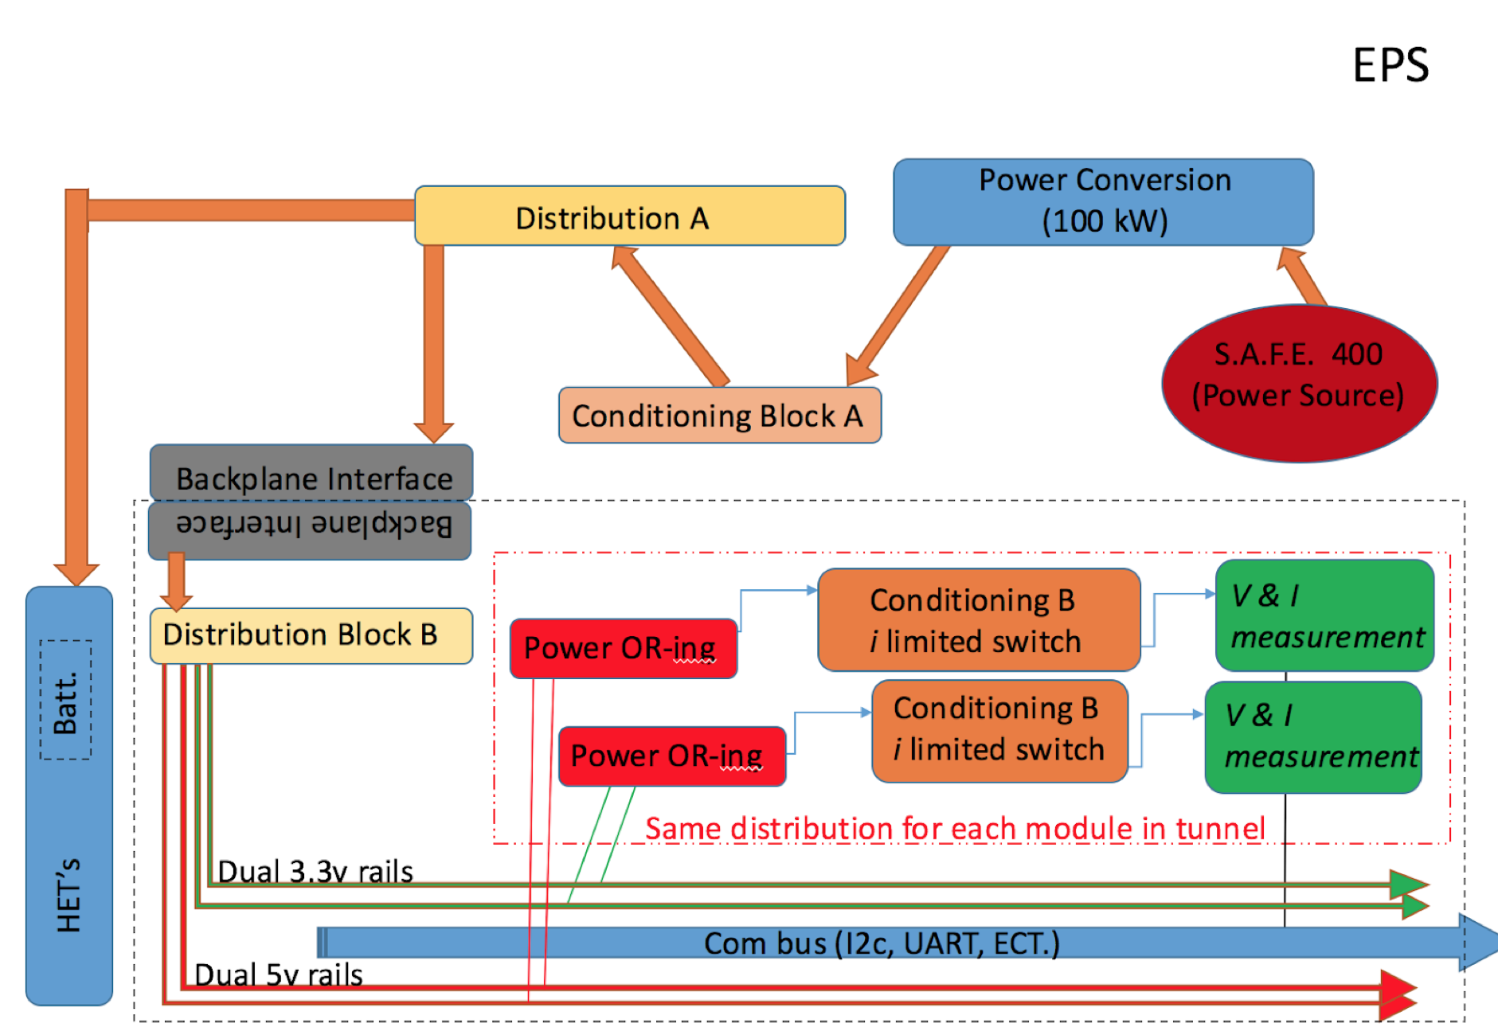

Figure 14: Electronic Power System (EPS) conceptual diagram.

**EPS Overview**

Argo’s electronic power system largely consists of two sections, A & B, which provide distribution and conditioning of the power provided by the Brayton-100/SAFE-400 power source. The block A distribution and conditioning system ensures that the power necessary for the Hall Effect Thrusters to achieve their required thrust is conditioned and available. Block B distribution and conditioning takes care of the power needs for the modules mounted within Argo’s tunnel architectures and is responsible for controlling the distribution of power between high-priority handling—mandatory aliveness functions—if power is at a premium, and nominal handling otherwise.

Power Distribution

*Block A:* Power made available from the SAFE-400 and 100 kW Brayton Cycle conversion system, while high-priority handling procedures are not underway to provide for mandatory aliveness functions, will be conditioned and distributed as to provide Argos Hall Effect Thrusters with the power for the required maneuvers underway. Power will be routed, conditioned, and divided to provide the backplane interface with the supply rails necessary for the modules populating the electronics tunnel.

*Block B:* Power distribution will be handed through the backplane interfaces 100, and 30-volt dual-redundant rails. These will run along the backplane where they are stepped down to lower voltages. The backplane will not exceed 30 centimeters in length, so we do not expect to see significant power loss at this stage. Each module will be configured to select the appropriate rail from the power bus when connected to the backplane. At each of these sockets, supply OR-ing and current limiting will help to ensure proper distribution.

Power Conditioning

*Block B:* Alongside power supply OR-ing and current limiting at each socket, the backplane will provide voltage and current measurement to the OBC via I2C bus to aid watchdog circuitry in order to ensure that the correct power is being provided to each module.

# Power

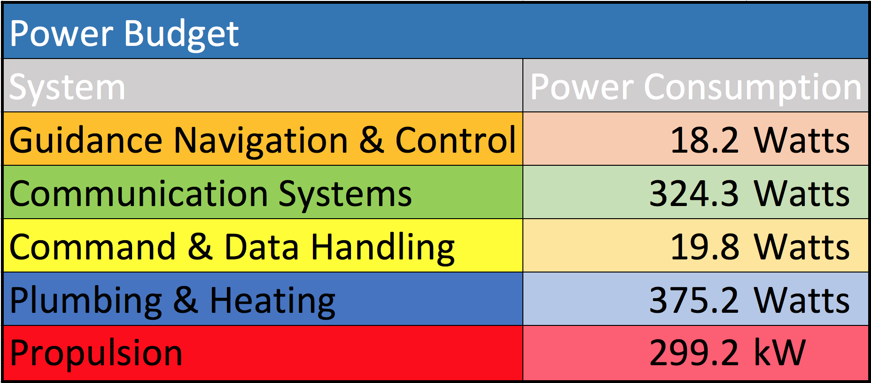

Table 7: Power Budget

**Power System Overview**

Argos power system consists of three SAFE-400 nuclear fission reactors, coupled with Brayton Cycle power nuclear power conversion modules capable of providing 100 kiloWatts of electrical power each. This heat-pipe power system will provide Argo with sufficient, reliable, and consistent power for all of the Hall effect thrusters and essentially render the remaining power demands of the electronics systems negligible.

**Nuclear Versus Solar**

While solar arrays are an easy solution for many satellite applications and would be the safest option for power, there are many issues that make solar an ineffective option for Argo. Argo would require a minimum of approximately 81,000 square feet of solar panels with equivalent energy density to those used on the ISS, that is about the size of 1.5 football fields. To be able to operate while in Earth’s shadow, Argo would also need to carry battery arrays and would need to almost double the size of the solar arrays to 150,000 square feet. Even with new solar cells that will be introduced within the next 5 to ten years, like those developed by Space Future, the power systems would weigh approximately 3 times as much as the SAFE reactors and their Braytons. We would also need to deal with inertial dampening of our acceleration due to the long arms of mass, and the risks of damaging the arrays when docking with cargo. All of these issues make solar a non-viable option for use with Argo.

**Safe Affordable Fission Engine 400 kW (SAFE-400) Reactor**

The SAFE-400 nuclear fission reactor is fueled by uranium nitride; widely considered safer, stronger, more tolerant to temperature and thermally conductive than other sources of nuclear fission. Each reactor is able to provide 400 KW and weigh approximately 512 kilograms each. The thermal radiators are oversized to compensate for times in which the thrusters are not in use.

**Brayton Cycle Power Conversion**

The Brayton Cycle power converters currently selected for use in Argo’s power system will make 100 kiloWatts of usable electric power available from each SAFE-400. The remaining 300 kW from each reactor will be radiated as waste heat. The power converters will encase the reactors and simply converts heat from the reactor into electrical energy. Thermoelectric generator technologies which use thermoelectric couple arrays and heat distribution blocks are currently being considered by our team. However, brayton power converters are currently our top candidate for conversion as research currently conducted on SAFE reactors at NASA readily cite it as the best, and most compatible, candidate for power conversion.

# Propulsion

**Propulsion Overview**

The propulsion system of Argo is selected to provide the thrust necessary to complete the required orbital maneuvers in a low cost, efficient manner. Argo is designed to complete a round-trip from LEO to LLO within 6 months transporting a payload of 34 metric tons. Additionally, the propulsion system is required to generate thrust required for pointing and payload rendezvous. These design requirements, along with a limited power supply and the necessity of limiting mass established the propulsion system sizing and specification.

**Electric Propulsion**

Electric propulsion was selected as the system of choice simply for its specific impulse. With the design payload mass of 34,000 kg and estimated structural mass of 6,000 kg. A chemical propulsion system with an estimated Isp of 450 s, utilizing a simple Hohmann transfer, would require 76,000 kg of propellant for the outbound trip alone.

It is simply not feasible to supply Argo with the required propellant for a chemical propulsion system operating regularly. Conversely, a propulsion system operating with higher Isp requires less propellant. Electric propulsion offers higher Isp for decreased thrust and high power requirements. (Neither of the trade-offs directly affects the mission parameters.)

**Hall Effect Choice**

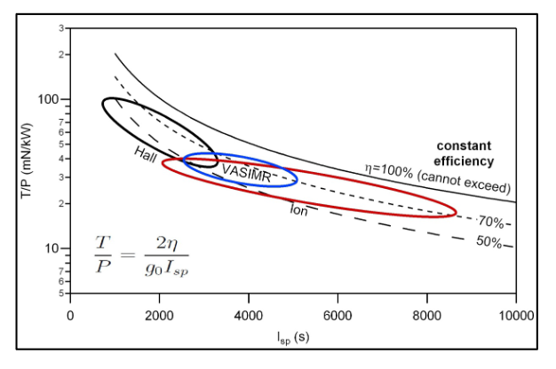

Figure 14: Thruster and input power vs specific impulse

Now the decision comes to which type of electric propulsion. We considered gridded electrostatic ion thrusters, Hall effect thrusters, and VASMIR. Structural and operational concerns limited the power supply to 3 SAFE reactors, delivering a total of 300 kW for use by the propulsion system.

An analog to the Argo project is NASA’s design work considering asteroid redirect missions. Figure 14 is their comparison of various electric propulsion systems[1].

Round trip mission duration requirement of 6 months places a lower bound on craft acceleration. Because of limited power and massive payload size, the craft needs high thrust per unit power (over 50 mN/kW). This places the propulsion system firmly in the Hall region.

We strongly considered VASMIR as the propulsion system because of it’s throttability and promising scalability, but ultimately declined for two reasons. One, Argo can not meet the power requirements without doubling the number of reactors. Two, VASMIR is strictly an experimental system, its reliability and operational lifespan is yet unknown.

Gridded Electrostatic ion thrusters were also considered. Nevertheless, operational thermal and vibration constraints limit the maximum size of the thrusters to around 40 kW each.[2] Argo would require an array of the thrusters adding to the complexity of the design. Although these thrusters are highly reliable with a long operational lifespan, Argo still is unable to meet the power necessary to achieve the required thrust.

Hall effect thrusters suffer from several flaws. Their operational lifespan is usually limited to 10,000 hours. Also, their Isp is lower, requiring additional propellant, but this cost can be passed on to our customers.

Ultimately, Hall effect thrusters were chosen as the propulsion system for Argo, in order to meet the design’s thrust requirements while still remaining within the 300 kW power budget. This selection, unfortunately reduces Isp and operational lifespan. The craft structures have been designed to be able to supply sufficient propellant. The cost of the additional xenon is acceptable in exchange for faster transits.

Engine Lifespan Optimization

As mentioned previously mentioned, the current lifespan of Hall-Effect thrusters is estimated at 10,000 operating hours or 415 days, about a year and two months of constant operation. For most low thrust orbital transfers, the thrusters are not operated continuously during the mission. Estimating engine operation to be around 50% of mission duration, the operational lifespan would be 830 days or two and a quarter years.

Argo’s desired operational lifetime is ten years, but anything above seven would be considered successful. A round trip is estimated to be around 190 days with a full load of cargo. Argo can reasonably expect to complete four trips, but possible wall degradation of the Hall effect thrusters means that future missions would not ensured to be successful.

There are four solutions to this problem. One, operate the thrusters for less time per transit, which would increase travel time and limit transit trajectories. Potential customers may grow weary and choose other space tug services with fewer delays. This solution does not solve the underlying problem. The second solution is to improve the thrusters by upgrading the cathode and anode walls to be more resistant to erosion. Research on technology for magnetic shielding of parts vulnerable to corrosion may increase thruster lifespan in the near future. If additional power becomes available, due to say increases in reactor efficiency, the thrusters can be run at greater power and higher Voltage drop for greater thrust and faster tansits or less operation time per transit. The fourth solution is to use Argo’s modular design to service and replace the hall effect thrusters to extend the craft’s operational lifespan.

X3 Engine Architecture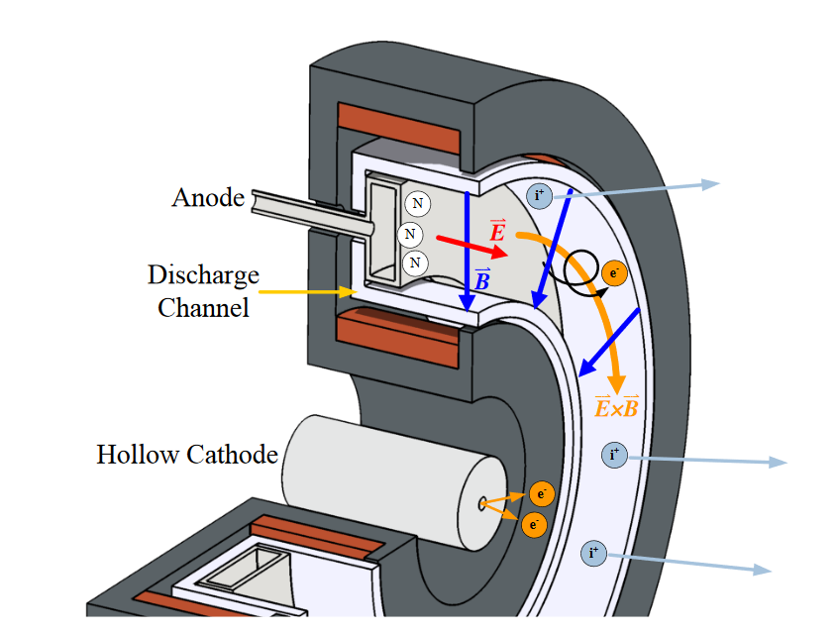

Figure 15: Engine Architecture

The prospective engine for Argo is based on University of Michigan's Plasmadynamics & Electric Propulsion Laboratory’s X3 hall effect thruster. The X3 is 3 channel, nested stationary plasma thruster designed to operate up to 200 kW and 8 N. The thruster has been characterized up to 100 kW and 5.4 N[3]. Argo plans to operate 3 thrusters of similar size at 100 kW each.

There are two major variations of Hall effect thrusters, stationary plasma thrusters and thrusters with anode layer. Stationary plasma thrusters operate by creating an axial electric field by biasing the anode to 400 V (in the case of the X3). A radial magnetic field is generated by electromagnetic coils. The X3 features a centrally-mounted cathode surrounded by three discharge channels with anodes and 2 electromagnets each.

The primary failure of hall effect thrusters is erosion of the wall due to ion contact. Current research exploiting equipotentialization along magnetic field lines shows great promise by utilizing magnetic shielding to maintain low ion velocities near the channel walls. The X3 is currently unshielded. However, it is reasonable to assume that shielded thrusters of the same class can and will be produced in the relatively near future. An advantage of the nested channel design is that failure of one channel does not lead to complete mission failure, Argo can still function using the other channels.

To begin operation, the cathode is heated and ignited to release seed electrons (thermionically) which are trapped at the discharge channel. When neutral propellant is introduced through the discharge channels, it is ionized by electron impact. The liberated electrons are trapped in *E x B* drift creating the Hall-effect region with strong electric potential. The propellant ions are accelerated through the region and eventually neutralized downstream by electrons emitted by the cathode.

This process naturally incurs oscillations which are still the subject of research. These oscillations possibly contribute to thruster performance and/or wall erosion. The breathing mode is the dominant discharge current oscillations. Thrusters with magnetic shielding also display a spoke mode. The spoke mode is a poorly understood phenomenon where thruster operation is dominated by spokes, azimuthally propagating oscillations in field strength which seem to improve thruster performance, but the impact of spokes on thruster lifespan is unknown.

Hall effect thruster performance is controlled by discharge voltage, discharge current, magnetic field strength, and propellant flow rate (cathode and anode). For flight vehicles, propellant flow is throttled to maintain constant discharge voltage and current. Thrusters are optimized for one throttle point, but their performance may be adjusted by varying propellant flow rate, anode voltage, and magnetic field strength[3]. However, the nested channel design allows the engine to be throttled by choosing which channels are operational, with no corresponding loss in performance or efficiency.

The X3 was surface treated with alumina spray to increase its emissivity. This was sufficient to manage the temperature of the thruster.[3] As a result we assume that no additional thermal management will be required, however additional research is required on operation in space as X3 is designed for operation on Earth.

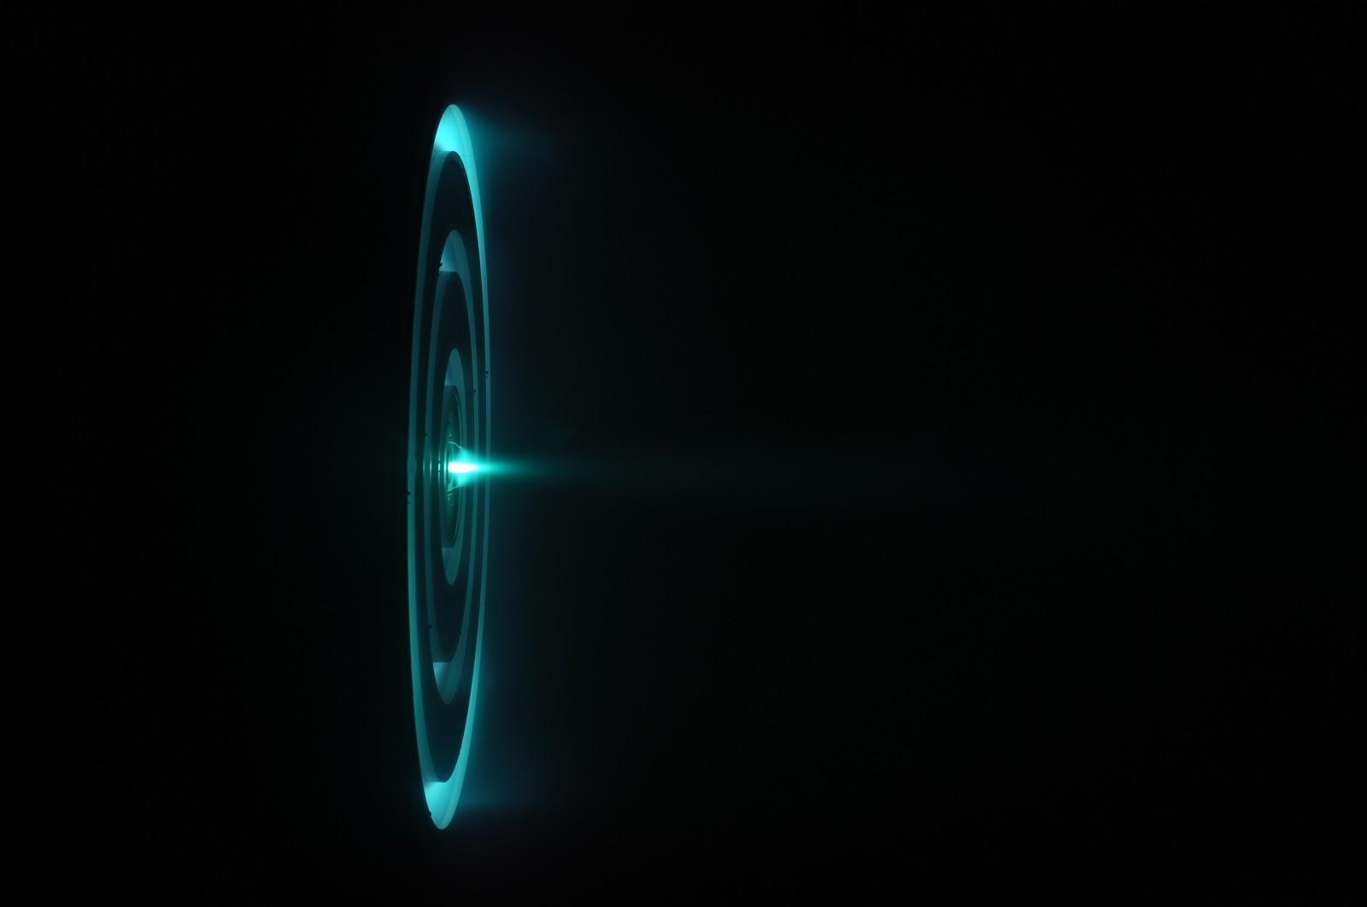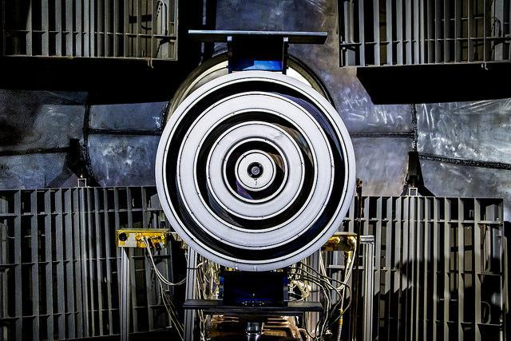

Figure 16,17: X3 Engine engine firing (top) and in test chamber before firing (bottom)

**Argo ACS System**

Argo needs to be able to accurately and reliably rendezvous and dock with payload. This requires an accurate and robust attitude control system. Argo is set to utilize a system of 12 cold gas thrusters which use the main propellant, xenon. Redundant thrusters can be added given the importance of each thruster for maneuvering to match various conditions. The valves and piping to feed the xenon will be placed inside the bus.

Six thrusters are mounted externally on the forward sections of the engine buses. They are mounted at the center of mass of the craft (without payload) to ensure accurate translational motion with minimal expenditure for docking. These thrusters are also responsible for spin control of the vehicle. When transporting sensitive cargo over long periods, Argo will need to spin slowly (normally at least a radian an hour) so as to limit concentrated sun exposure of any payload surface.

Argo needs to get close enough to and stop before the payload so that it can deploy its robotic docking arm. Three cold gas thrusters are mounted on both the front and rear of the craft for braking and docking control. For the primary pointing control during transit, the hall effect thruster channels will be throttled appropriately.

 

Figure 18, 19: Black circles in corners represent the placement of the forward, side and rear facing ACS thrusters

**Engine Verification Overview**

Any engine that we produce or purchase will need to be held to exacting performance criteria. Prior to vehicle launch, the engines will need to be verified, with all other systems, on the ground. Safely during RPO, additional tests will be required to ensure that all systems are operating as anticipated, before transporting our very heavy, and therefore expensive, payloads.

Dirtside Validation

Because Hall effect thrusters similar to the X3 are not commercially available, the engines will need to be custom ordered and individually tested in a sufficiently large vacuum test facility. Such facilities include University of Michigan PEPL’s Large Vacuum Test Facility, where X3 was tested the first time, or NASA Glenn. The supplier will need to test the engines for nominal performance in terms of specific impulse, thrust, and thermal behavior and report their findings prior to acceptance. Each channel must be tested independently and jointly.

Each engine will need to be qualified for performance with different mass flow, discharge current and voltage, and magnetic fields, in order to improve the accuracy of our control system which will be responsible for handling the behavior of the engines. Then we will need to simulate recovery from channel failure, so that the control system properly detects and stops the use of a channel compromised during a mission.

It would be beneficial to test fourth engine through Highly Accelerated Life Testing (HALT) in order to experimentally validate the thruster lifespan. The thruster will be tested in intervals. After each interval erosion is measured used to model future erosion. The thruster is machined to artificially simulate erosion, and then tested for another interval and the process repeats.

After Argo is assembled, the craft will need to be tested as a whole. These tests will include power tests of power regulation, electronic control, detection and safe handling of failure scenarios, and et cetera. One test will verify correct assembly of the attitude control system, verifying proper thruster alignment and qualifying the system performance prior to launch. After determining that Argo can be controlled accurately with minimal performance loss from design, the engine system is ready for launch.

Orbital Verification

Completing an entire trial mission with a dummy payload is impractical considering the limited lifetime of the hall effect thrusters. As a result the scope of orbital tests will be limited. Groundside tests should have already verified each engine’s performance individually. Instead, the primary objective of orbital tests is to ensure no damage to the propulsion system during launch and to verify the results of the groundside tests.

We anticipate verifying the attitude control system, accuracy of thrust controls, and position tracking systems through a rendezvous with a dummy payload. Precise data acquisition will be handled by an array of high performance accelerometers. Only once Argo has demonstrated that it can reliably dock with payload, is it time to service paying customers. For best results and additional verification, the first mission should be from LEO to GEO, demonstrating that the vehicle is fully operational.

# Orbital Mechanics Approximation

The Argo transfer mission requirements are approximated based on low thrust trans lunar injection calculations. All of the approximations use craft acceleration (thrust normalized by mass).

For the return leg of our mission, the craft is expected to travel without any payload. Argo should mass 6,000 kg and have a thrust of 15 N. This yields a thrust acceleration of 2.5*10-4 g. This thrust range is best approximated by Herman 1998 which models craft with 1.0*10-4 g of acceleration.[4] Taking Herman’s figures as a lower bound, the return trip should take less than 33 days LLO to GEO and less than 760 kg of propellant. From CCAR, the LEO to GEO transit will take under 7 days. In total, the return trip is estimated to take 40 days and 1000 kg of xenon.[5]

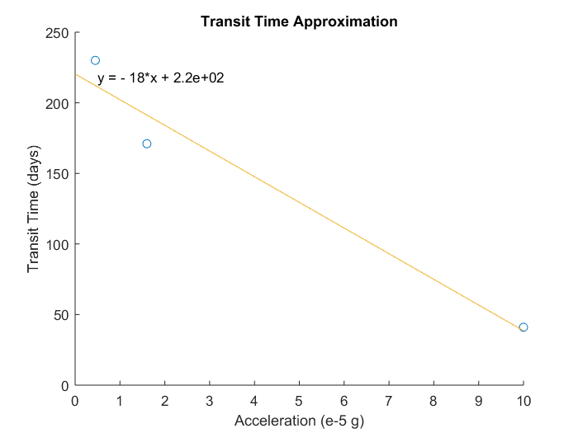

Figure 20: Transit Time vs Acceleration

For the outbound leg, the craft is projected to transport a 34,000 kg payload with its 6 mT bus, and 1,000 kg of propellant in reserve for the return trip. This yields a thrust acceleration of 3.7*10-5 g. Unfortunately, we were unable to locate research in this range. A NASA presentation on Lunar Cubes discusses trajectories with accelerations of 4.5*10-6 g and 1.6*10-5 g.[6] Using a first order linear approximation with NASA’s and Herman’s data (figure 20), we estimate a transit time of 150 days. Herman 1998 places an upper bound on fuel consumption at 5,200 kg of propellant.

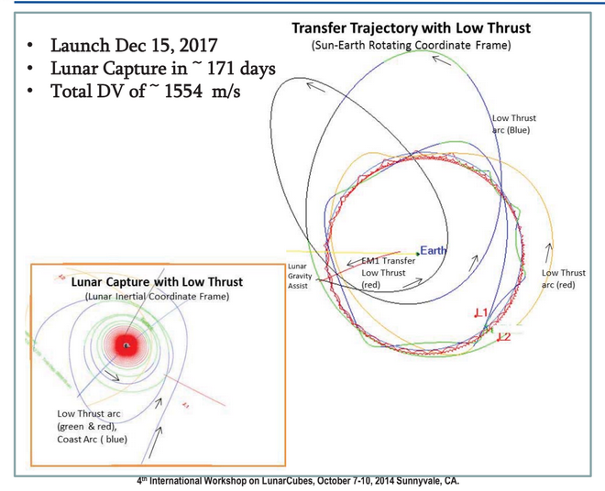

Figure 21: NASA LunarCube EM-1 Transfer Trajectory

For a complete mission, we anticipate it to take 190 days plus time in orbit for payload rendezvous. We anticipate the propulsion system will require at most 6,200 kg. Under a worst case scenario, requiring excessive use of the ACS system, the craft will use no more than 7,000 kg of propellant.

Low thrust trajectory optimization is very difficult, because it requires a very good guess at possible trajectory. Interesting work is being done in the field of machine learning for astrodynamic trajectories.[7] As part of Argo’s R&D, more accurate simulations will be run to optimize Argo’s transits. On board computer systems will be loaded with software to communicate with mission control and adjust Argo’s trajectory in transit as updated position data is captured.

# 

# Propellant Feed

**Design and Overview**

The propellant feed system of Argo is designed to deliver high pressure supercritical Xenon from the main storage tank to the 3 different hall effect thrusters and their respective anodes and cathodes. Several different kinds of valves are being used in the system as well as multiple pressure transducers and temperature sensors to determine if the system is operating nominally or not. Filters are being incorporated before several valves to ensure that the Xenon being delivered to the thrusters is as pure as possible for other particulates could increase the deterioration time of parts in the thruster and jeopardize the entire mission or contract.

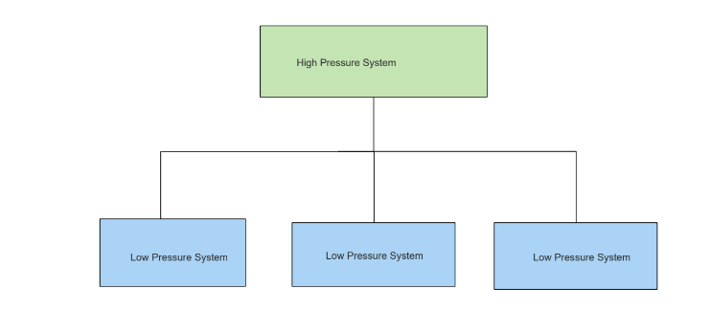

Figure 22: Schematic of System

This is a general overview of the entire system while the P&ID (Piping and Instrumentation Diagram) below is details the actual system. The first pipe that leads into the system will be large enough to deliver the correct amount to all 3 thrusters.Testing will be done to verify if correct measurements of the gas are being delivered and the reliability/durability of the system. Though adding weight is not always optimal, due to a desired long service life, a redundant system may be added where necessary. I.e. a second high pressure system (excluding main storage tank) to be added in and a second low pressure system for each thruster for a total of 6 low pressure systems. The long operational lifespan desired of Argo would mean lots of cycles for the all components which could lead to a breakdown or failure in the system. Having a redundant system could add life which might offset the added weight and cost.

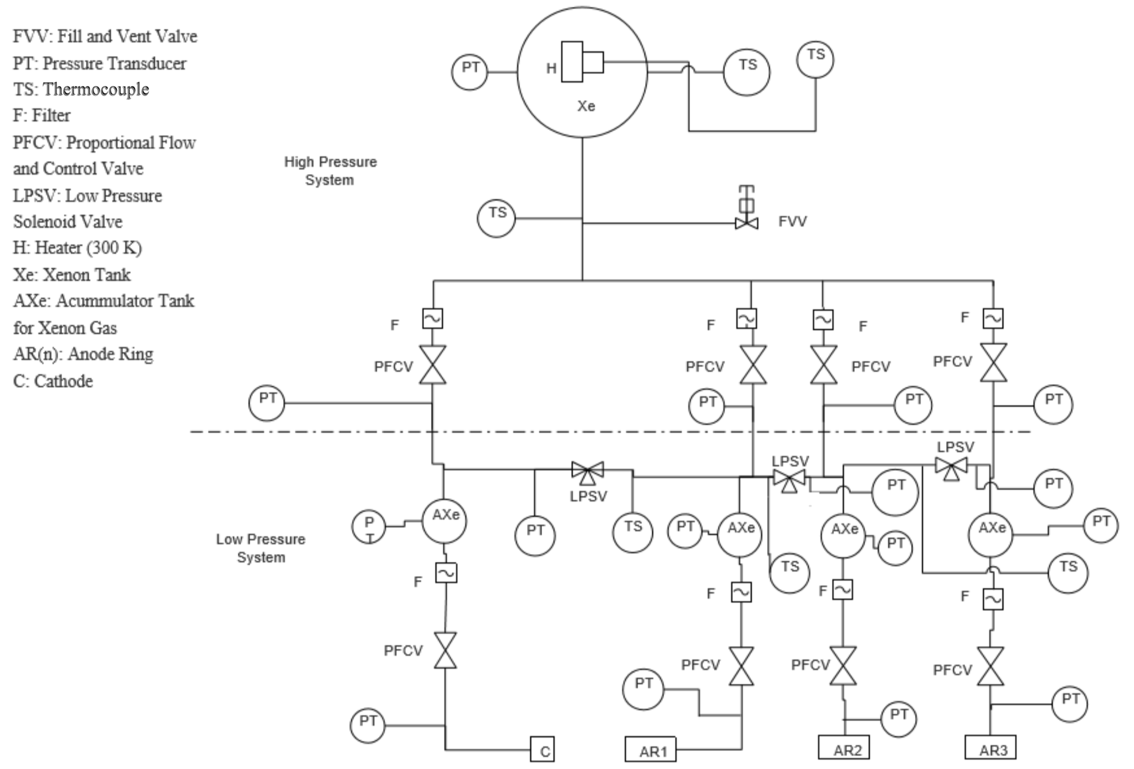

Figure 23: Xenon Feed System

*Note: The pressure drops after the first set of PFCVs and becomes a low pressure system. The dashed line represents this

Pressurization and heating

Initial pressurization of the tank will be held on the ground and the tank will be pressurized to a pressure of anywhere between 1,000-1,500 psi to compensate for gas leaving the system over time. A heater will be put on the outside surface of the tank to make sure that the temperature of the tank remains about 300 K so that the xenon maintains its supercritical state. To keep the tank pressurized, helium gas will be added to the system so that the pressure in the tank is kept above the supercritical point. This would make refueling a more complicated mission however. Another possibility is to over pressurize the initial state is well above the supercritical point. The heating will be done from the outside.

Valves

Valves of the xenon feed system are some of the most important parts within the system. Multiple proportional flow and control valves (PFCVs) are used to regulate pressure and flowrate throughout the initial high pressure system and the following low pressure system before the thruster head. The valves that would be used are Moog 51E339 PFC valves as these valves give the desired conditions for the hall effect thrusters and allow for control of the flow in both pressure and mass flow rate. Solenoid valves branch between the channels and are normally closed. These valves serve to get to another branch of the system if something goes wrong within the system, avoiding entire system failure. The valves be pneumatically actuated.

Flow Control

The flow of Xenon is mostly controlled by the PFC valves as they are regulating the pressure drops and the mass flow rates inside the piping. Pressure relief valves will be added at various places in the system, such as in the low pressure system. Orifices will be added in the valves to get the exact flow rate desired in each branch of the feed system. These orifices will be placed with the filters.

Tanks

The Xenon storage tank is designed to hold 10 tons of supercritical xenon. It must hold this fuel for the duration of the mission and afterwards be able to be partially refilled. Although only an estimated 7 tons is needed for a roundtrip, the remaining 3 tons are used for ACS thruster operations (rotation and braking) and emergency maneuvers. Other tanks in the system are accumulator tanks for Xenon. These tanks are much smaller than the main storage and serve as a way to hold Xenon before it reaches the thrusters. The first set of PFC valves are not rated for the entire flow rate due to the higher pressure gas coming from the tank. To counteract this, while in a parking orbit after the initial separation from the rocket the tanks will fill so that during thruster operation, the correct amount of gas will be reaching the thruster head. The thrusters are not being operated the entire time so gas is continuously allowed to flow into the tanks. These accumulator tanks will be of the same kind as the main storage tank, just scaled down versions.

The tank will be fabricated with a safety factor and the maximum pressure it will ever experience is 1,500 psi. According to [Ray], the tanks have an operating pressure limit of over 5,000 psi. Tank material is talked about in the structures part of the document. The pressure in all tanks is monitored closely. If adverse pressure is detected, the system will be vented. The vent valve is located in such a way that venting can occur with cargo safely.

Anode Ring Flow Control

In Figure 23, there are three branches of piping that go to the anode. Each anode ring requires the ability to be throttled. To allow this, flow goes directly to each ring individually. This also means if one ring fails, the entire thruster is not useless as flow is still reaching the other thruster heads during operation. Other thrusters will have to be scaled down to accommodate these changes in thrust so that a constant trajectory is maintained. Input power is also able to be controlled to the thrusters which will result in a change in thrust output as well.

**ACS System**

An attitude control system consisting of monopropellant thrusters are placed throughout the spacecraft. Groups of 2 thrusters will be placed together along axis and will serve to correct small adjustments in the direction of the spacecraft. It will also serve as a pressure relief system in the case that the Fill and Vent valve can not handle all of the relief. The thrusters will be most likely sourced from Moog Space group. Xenon could be used as the propellent so that hydrazine and its own pressurization system is not needed.

**Sensors**

Sensors are necessary to understand the performance of the propellant feed system. Multiple pressure transducers and temperature sensors will be placed throughout to make sure all the parts are within their operational limits. If the sensors show that part of the system is failing, than the system will either have to be shut down and restarted or flow will be redirected through another pathway.

**Calculations for tank storage**

|  |  |  |
| --- | --- | --- |
| Parameter | Parameter Variable | Calculation |
| Tank Size | Vtank | V = = 7.7 m3 |
| Tank Radius | Rtank | R = ${\sqrt[3]{\frac{3V}{4ℼ}}}_{}^{}$ = 1.23 m |

Table 7: Tank Calculations

The desired max mass flow rate to the anode is 70 mg/s to each of the rings. The mass of the Xenon that is desired to be carried is 10 metric tons.

Other variables that would be needed tested for or experimentally measured are:

* Head Loss in Pipes, both major and minor losses. Loss coefficients for all valves would be known values.
* Leakage rates of valves and accumulator tanks.
* Piping length and diameter would be determined before testing. Other pipe factors to be considered would be friction factor, the roughness of the pipes being used.
* Power input to control all valves would also be determined.
* Viscosity of the Xenon flowing in the tubes would be found as well if the flow is turbulent or laminar
* Orifices in the pipes may be added to add further control over the flow.

**Refueling Overview**

A space tug should be a robust spacecraft that can ideally perform multiple missions over the course of its service life. However, launch vehicle capacities limits how much fuel is able to be sent up on launch, so a refuelable system needs to be designed and implemented to increase service life. Refueling needs to have the correct pressure so that gas flows into the tanks on board Argo. The max pressure of the refueling vessel would have to be determined by the mission contractor as it is their responsibility to ensure that the fuel arrives with the cargo. If the cargo load does not permit this, a separate launch vehicle exclusively for refueling purposes would need to be launched as well.

Cargo Refueling

To refuel the Argo space tug, a fill and vent valve is able to be accessed externally. When fuel is sent up with cargo, or separately by itself, a container with the fuel will approach the spacecraft. When it gets close enough, a robotic arm similar to the one that grabs incoming vehicles to the International Space Station will be used albeit on a smaller scale. Once the arm slides the attachments together, ground control will allow the valve to open and more fuel to enter the system. Propellent tanks can also be integrated into cargo and can fill Argo’s tank and then be disposed of before departure from LEO. Testing would be done to determine which would work better. The two major factors that would be tested for the refueling method would be to see how control of the tanks Fill and Vent Valve is done and how pressure inside the tank is maintained. For the method where tanks are ejected, testing of the ejection system and hooking up of the tank to the rest of the propellant feed system.

Another possibility that was brought up in the structures system is that refueling would be different with multiple smaller tanks. A possible solution is portrayed below.

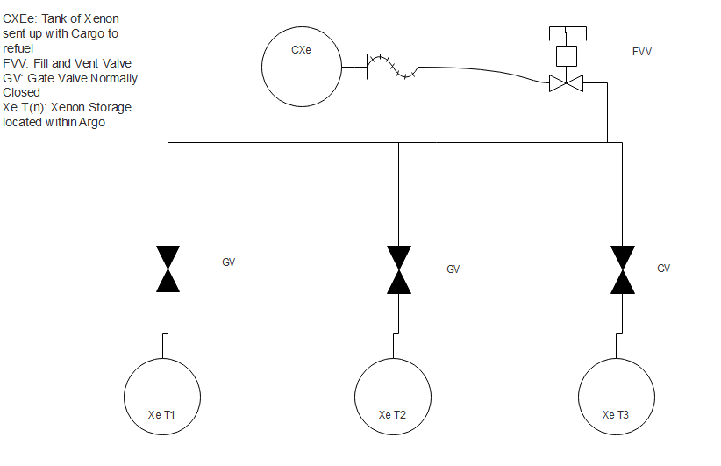

Figure 24: Possible refueling method with multiple tanks

The system would work with the one gate valve opening and xenon flowing into the tank. The valve closing once the tank is filled and then the Fill and vent valve closing and any excess gas in the system being released. Then a gate valve opened and the fill and vent valve opening after. This process repeats until all the tanks are refilled. The resupply vehicle would then detach and normal operations would resume.

Another possibility to refuel Argo would be a replaceable external tank. This solution to refueling could possibly work, however, a complicated ejecting mechanism would have to be fabricated to ensure reliable ejection of the tank as well as equipment to align the tanks with the proper propellant feed tubes. This would be a tricky task and has more room for error than the above described system.

Refueling Station

A possible long term refueling solution would be an orbital refueling station. Bulk amounts of xenon propellent can be launched to LEO where it can be docked with a station that then offloads the tank. The empty launch tank then returns to earth and the tug can move to dock with the station where it can refuel. This refueling station could also serve as a docking hub for multiple space-tugs. If Argo performs well, then this would be feasible and allows for multiple missions at one time. This proposed facility could be similar to an unmanned ISS. If the station becomes manned, then diagnostics and if needed, repairing and retrofitting operations could be performed further increasing the lifespan of the space tug. In both cases, remote robotic could be used for upgrades and servicing.

# Future

Argo is simply a stug platform that can have many uses beyond what has been described. Argo is a flexible vehicle capable enough so that it can be utilized in new applications in an ever advancing space economy .If these markets prove to be profitable, there is a lot of room for expansion. As mentioned in the refueling section of the document, a possibility for a space station is not out of the question. Though many years of research and development would have to occur to get something like that off the ground, the idea is still there. Argo is designed to be modular and retrofittable. If a refueling station is able to exist then perhaps something like the below picture from *2001: A Space Odyssey* is not too far out of the picture.

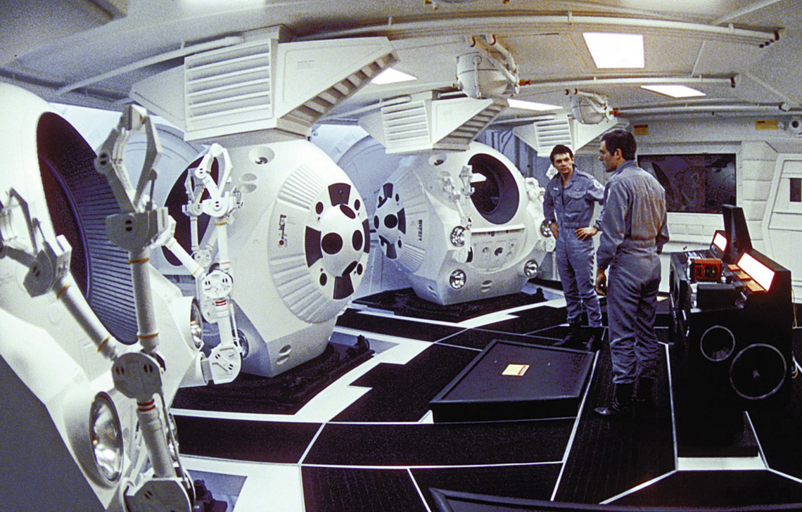

Figure 25: David Newman (Kier Duella) and Frank Poole (Gary Lockwood) in the cargo bay of *Discovery One.* Copyright 1968 ,2001 by Turner Entertainment Company

The space-tugs would most likely be externally docked with repair-men/astronauts doing EVAs perform maintenance rather than an internal cargo bay. With Argo, there are many there are many possibilities.

# Sources

**Business:**

“In-Orbit Servicing Market Opportunity Exceeds $3 Billion.” GlobeNewswire News Room, GlobeNewswire, 30 Jan. 2018, globenewswire.com/news-release/2018/01/30/1314007/0/en/In-Orbit-Servicing-Market-Opportunity-Exceeds-3-Billion.html.

**Power:**

Komerath, Dessanti. “Brayton Cycle Conversion For Space Solar Power.” Georgia Institute of Technology, http://adl.gatech.edu/research/spg/papers/InCA_AIAAJPP.pdf

Mason, Lee. “A Comparison of Brayton and Stirling Space Nuclear Power Systems for Power Levels from 1 Kilowatt to 10 Megawatts,” *NASA.gov,* https://ntrs.nasa.gov/search.jsp?R=20010016863 2018-04-04T03:14:24+00:00Z

Mason, Shaltens, Dolce, Cataldo. “Status of Brayton Cycle Power Conversion Development at NASA GRC,” *NASA.gov,* https://ntrs.nasa.gov/search.jsp?R=20020038204 2018-04-04T03:13:55+00:00Z

“Multi-Mission Radioisotope Thermoelectric Generator (MMRTG),” *NASA.gov,* https://mars.nasa.gov/msl/files/mep/MMRTG_FactSheet_update_10-2-13.pdf

**Structures:**

Explorations, Space. “Falcon 9 Launch Vehicle, Payload Users Guide, Revision

2. ”*Www.spacex.com*, 21 Oct. 2015, http://www.spacex.com/sites/spacex/files/ falcon_9_users_guide_rev_2.0.pdf

Timet. “Titanium - Comparison of Properties with Other Metals.” *AZoM.com*, 1 Aug. 2017,

www.azom.com/article.aspx?ArticleID=1298.

Ray, David M, et al. “High Pressure Composite Overwrapped Pressure Vessel (COPV) Development Tests at Cryogenic Temperatures.” *NASA*, NASA, 1 Jan. 2008, ntrs.nasa.gov/search.jsp?R=20080009730.

**Propulsion :**

Dachwald, “Low-Thrust Trajectory Optimization and Interplanetary Mission Analysis Using

Evolutionary Neurocontrol,” Deutscher Luft- und Raumfahrtkongress, 2004.

“Dual-Stage Gridded Ion Thruster (DS4G),” *Advanced Concepts Team, ESA.int*, http://www.esa.int/gsp/ACT/pro/projects/ds4g_overview.html

Folta, Dichmann, Clark, Haapala, and Howell, “LunarCube Transfer Trajectory Options,” *4th*

*International Workshop on LunarCubes*, 2014.

Garcia, Roberto. “Asteroid Robotic Redirect Mission (ARRM) Solar Electric Propulsion (SEP) Other Trades Study (OTS),” *NASA.gov*, https://www.nasa.gov/sites/default/files/files/Other-Trades-Study-Garcia-TAGGED.pdf

Hall, Scott James, “Characterization of a 100-kW Class Nested-Channel Hall Thruster,”

University of Michigan, PhD Dissertation, 2017.

Herman, Albert, “Optima, Low-Thrust, Earth-Moon Transfer,” *Journal of Guidance, Control, And Dynamics*, Vol 21, No 1, January-February 1998.

Stansbury, Sarah, “Low Thrust Transfer to GEO: Comparison of Electric and Chemical

Propulsion,” CCAR, University of Colorado Boulder, 2009. http://ccar.colorado.edu/asen5050/projects/projects_2009/stansbury/

**Propellant feed:**

Barbaritis, Joseph K, and Paul T King. “XENON FEED SYSTEM PROGRESS.” *DTIC*, AIAA, 9 July 2006, www.dtic.mil/dtic/tr/fulltext/u2/a456850.pdf.

Bushway, Edward M, et al. “A Xenon Flowrate Controller for Hall Current Thruster Applications.” *SpaceGrant*, IEPC, 2001, erps.spacegrant.org/uploads/images/images/iepc_articledownload_1988-2007/2001index/2002iepc/papers/t14/315_1.pdf.

Bushway, Edward D, et al. “NSTAR Ion Engine Xenon Feed System: Introduction to System Design and Development .” *SpaceGrant*, erps.spacegrant.org/uploads/images/images/iepc_articledownload_1988-2007/1997index/7044.pdf.

Goebel, Dan M, and Ira Katz. *Fundamentals of Electric Propulsion: Ion and Hall Thrusters*. Wiley, 2008.<https://descanso.jpl.nasa.gov/SciTechBook/series1/Goebel__cmprsd_opt.pdf>

Kim, Younho, et al. “Development of Xenon Feed System for a 300-W Hall-Thruster .” *SpaceGarnt*, IEPC, 20 Sept. 2009, erps.spacegrant.org/uploads/images/images/iepc_articledownload_1988-2007/2009index/IEPC-2009-061.pdf.

Patterson, Michael J, and Scott W Benson. “NEXT Ion Propulsion System Development Status and Performance .” *AIAA*, AIAA, 8 July 2007, www.grc.nasa.gov/WWW/ion/pdfdocs/AIAA-2007-5199.pdf.

Pehrson, David M. “Continuing Development of the Proportional Flow Control Valve (PFCV) for Electric Propulsion Systems .” *NASA*, NASA, 17 Sept. 2007, www.erps.spacegrant.org/uploads/images/images/iepc_articledownload_1988-2007/2007index/IEPC-2007-346.pdf.

Ray, David M, et al. “High Pressure Composite Overwrapped Pressure Vessel (COPV) Development Tests at Cryogenic Temperatures.” *NASA*, NASA, 1 Jan. 2008, ntrs.nasa.gov/search.jsp?R=20080009730.

Starling, Dan A. “Propellant Feed Control for Ion Engines.” *Naval Postgraduate School*, 1996.

Theskin, J.C., et al. “Composite Overwrap Pressure Vessels: Mechanics and Stress Rupture Lifing Philosophy.” *NASA*, NASA, 23 Apr. 2007, ntrs.nasa.gov/search.jsp?R=20070022369.

**Electronics:**

Architectures of Onboard Data Systems. (n.d.). Retrieved from http://www.esa.int/Our_Activities/Space_Engineering_Technology/Onboard_Computer_and_Data_Handling/Architectures_of_Onboard_Data_Systems

Bechtel, R. (2013). Multi-Mission Radioisotope Thermoelectric Generator (MMRTG). *NASA Facts*. Retrieved April 11, 2018, from https://mars.nasa.gov/msl/files/mep/MMRTG_FactSheet_update_10-2-13.pdf.

High Data Rate S-Band Transmitter. (n.d.). Retrieved from https://www.isispace.nl/product/isis-txs-s-band-transmitter/

Huber, F. (n.d.). FPGA based On-Board Computer System for the “Flying Laptop” Micro-Satellite. Retrieved from https://pdfs.semanticscholar.org/17e4/d734e6a914b50ddbd788dbeca01b907ad7c9.pdf

Komerath, N. (n.d.). Brayton Cycle Conversion For Space Solar Power. *American Institute of Aeronautics and Astronautics*. Retrieved April 11, 2018.

Mason, L. S., Shaltens, R. K., Dolce, J. L., & Cataldo, R. L. (2002). Status of Brayton Cycle Power Conversion Development at NASA GRC. *NASA Technical Reports Server*. Retrieved April 11, 2018, from https://ntrs.nasa.gov/search.jsp?R=20020038204.

Mason, L. S. (2001). A Comparison of Brayton and Stirling Space Nuclear Power Systems for Power Levels from 1 Kilowatt to 10 Megawatts. *NASA, Glenn Research Center, Cleveland, Ohio*. Retrieved April 11, 2018, from https://ntrs.nasa.gov/search.jsp?R=20010016863.

On board computer. (n.d.). Retrieved from https://www.cubesatshop.com/product/on-board-computer/

“On the Challenge of a Century Lifespan Satellite.” *Egyptian Journal of Medical Himan Genetics,* Elsevier, 10 June 2014, www.sciencedirect.com/science/article/pii/S0376042114000529

Rao, V., & Pal, S. (2009, April). High Bit Rate Data Transmitting System for Remote Sensing Satellites. Retrieved April 11, 2018, from https://pdfs.semanticscholar.org/c31f/890c507bd8c17abf6c3954cc600c67ebd856.pdf

Indian Space Research Organisation

S Band Filters. (n.d.). Retrieved from https://www.southwestantennas.com/products/filter-modules-diplexers-triplexers/s-band-filters

Safe affordable fission engine. (2018, April 10). Retrieved from https://en.wikipedia.org/wiki/Safe_affordable_fission_engine

Zeynali, Omid, et al. “The Design and Simulation of the Shield Reduce Ionizing Radiation Effects on Electronic Circuits in Satellites.” *Electrical and Electronic Engineering,* 2011, http://article.sapub.org/pdf/10.5923.j.eee.20110102.16.pdf

Zeynali, Omid, et al. “Shielding Protection of Electronic Circuits against Radiation Effects of Space High Energy Particles.” *IMedPub*, Pelagia Research Library , 2012, www.imedpub.com/articles/shielding-protection-of-electronic-circuits-against-radiation-effects-of-spacehigh-energy-particles.pdf.